DATE: 1-11-21
WEBLEM 11
Introduction To Sequence Alignment

BLAST:
A sequence similarity search often provides the first information about a new DNA or protein sequence. A search allows scientists to infer the function of a sequence from similar sequences. There are many ways of performing a sequence similarity search, but probably the most popular method is the “Basic Local Alignment Search Tool” (BLAST) (1, 2). BLAST uses heuristics to produce results quickly. It also calculates an “expect value” that estimates how many matches would have occurred at a given score by chance, which can aid a user in judging how much confidence to have in an alignment.

As the name implies, BLAST performs “local” alignments. Most proteins are modular in nature, with one or more functional domains occurring within a protein. The same domains may also occur in proteins from different species. The BLAST algorithm is tuned to find these domains or shorter stretches of sequence similarity. The local alignment approach also means that an mRNA can be aligned with a piece of genomic DNA, as is frequently required in genome assembly and analysis. If instead BLAST started out by attempting to align two sequences over their entire lengths (known as a global alignment), fewer similarities would be detected, especially with respect to domains and motifs.

- BLASTN:
The BLASTN nucleotide-nucleotide search looks for more distant sequences.

- BLASTP:
BLASTP performs protein-protein sequence comparison, and its algorithm is the basis of many other types of BLAST searches such a BLASTX and TBLASTN.

- PHI-BLAST:
PHI-BLAST (Pattern-Hit Initiated BLAST) is a search program that combines matching of regular expressions with local alignments surrounding surrounding the match. The most important features of the program have been incorporated into the BLAST software framework partly for user convenience and partly so that PHI-BLAST may be combined seamlessly with PSI-Blast. Other features that do not fit into the BLAST framework will be released later as a separate and/or separate web page query option.

- PSI-BLAST:
PSI-BLAST first performs a BLASTP search to collect information that it then uses to produce a Position-Specific-Scoring-Matrix (PSSM). A PSSM for a query of length N is an N x 20 matrix. Each of the N columns corresponds to a letter in the query, and each column contains 20 rows. Each row corresponds to a specific residue and describes the probability of related sequences having that residue at that position. PSI-BLAST can then search a database of protein sequences with this PSSM.

FASTA:
At EMBL-EBI, we make the world’s public biological data freely available to the scientific community via a range of services and tools, perform basic research and provide professional training in bioinformatics. We are part of the European Molecular Biology Laboratory (EMBL), an international, innovative and interdisciplinary research organization funded by over 20 member states, prospect and associate member states.
ASTA (pronounced FAST-AYE) is a suite of programs for searching nucleotide or protein databases with a query sequence. FASTA itself performs a local heuristic search of a protein or nucleotide database for a query of the same type. FASTX and FASTY translate a nucleotide query for searching a protein database. TFASTX and TFASTY translate a nucleotide database to be searched with a protein query. Optimal searches are available with the programs SSEARCH (local), GGSEARCH (global) and GLSEARCH (global query against local database).

- FASTAp;
This tool provides sequence similarity searching against protein databases using the FASTA suite of programs. FASTA provides a heuristic search with a protein query. FASTX and FASTY translate a DNA query. Optimal searches are available with SSEARCH (local), GGSEARCH (global) and GLSEARCH (global query, local database).

- FASTAn:
This tool provides sequence similarity searching against nucleotide databases using the FASTA suite of programs. FASTA provides a heuristic search with a nucleotide query. TFASTX and TFASTY translate the DNA database for searching with a protein query. Optimal searches are available with SSEARCH (local), GGSEARCH (global) and GLSEARCH (global query, local database).

DATE: 1-11-21
WEBLEM 11/a
(URL: https://blast.ncbi.nlm.nih.gov/Blast.cgi)

Aim:
To study the Query ‘Keratin’ in BLASTn.

Introduction:
As the name implies, BLAST performs “local” alignments. Most proteins are modular in nature, with one or more functional domains occurring within a protein. The same domains may also occur in proteins from different species. The BLAST algorithm is tuned to find these domains or shorter stretches of sequence similarity. The local alignment approach also means that an mRNA can be aligned with a piece of genomic DNA, as is frequently required in genome assembly and analysis. If instead BLAST started out by attempting to align two sequences over their entire lengths (known as a global alignment), fewer similarities would be detected, especially with respect to domains and motifs.
- The BLASTN nucleotide-nucleotide search looks for more distant sequences.

Rhodopsin, also called visual purple, pigment-containing sensory protein that converts light into an electrical signal. Rhodopsin is found in a wide range of organisms, from vertebrates to bacteria. In many seeing animals, including humans, it is required for vision in dim light and is located in the retina of the eye specifically, within the tightly packed disks that make up the outer segment of the retina’s photoreceptive rod cells, which are specially adapted for vision under low-light conditions.
Rhodopsin was discovered in 1876 by German physiologist Franz Christian Boll, who observed that the normally reddish purple frog retina turned pale in bright light. The fading of colour was later attributed to the destruction of rhodopsin, via a process known as bleaching. Bleaching and the subsequent regeneration of rhodopsin are major steps in the visual cycle—the series of biochemical reactions that is critical for vision in low light.

Methodology:
- Open the homepage of blast.
- After that click the Blastn.
- Enter the sequence for keratin taken by Genebank.
- Open the result page.
- Interpret the result.

Observation:
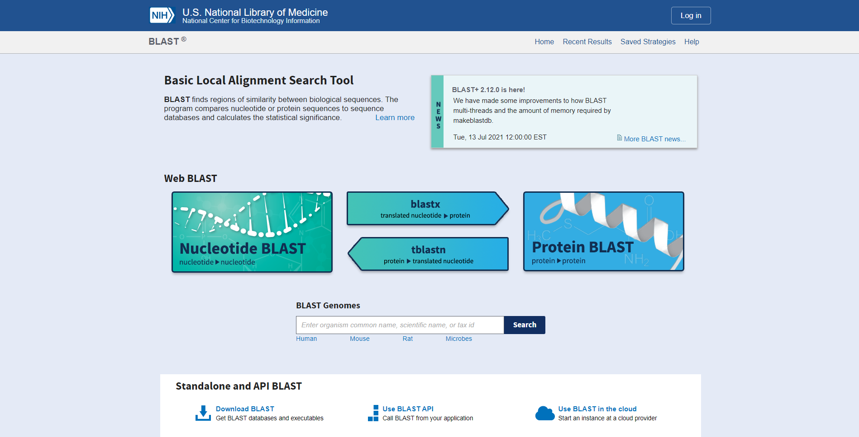Fig1. Homepage of BLAST

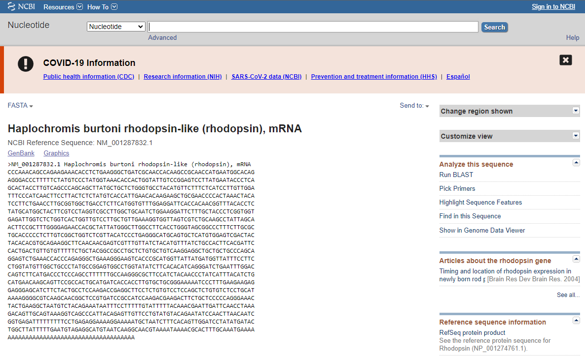Fig2. Fasta sequence taken from genebank

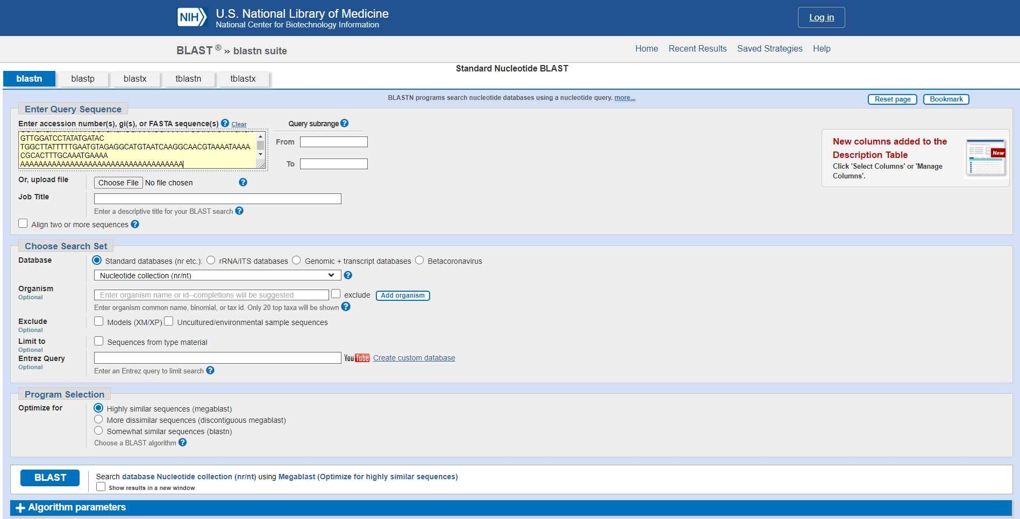Fig3. Search bar for blastn with sequence.

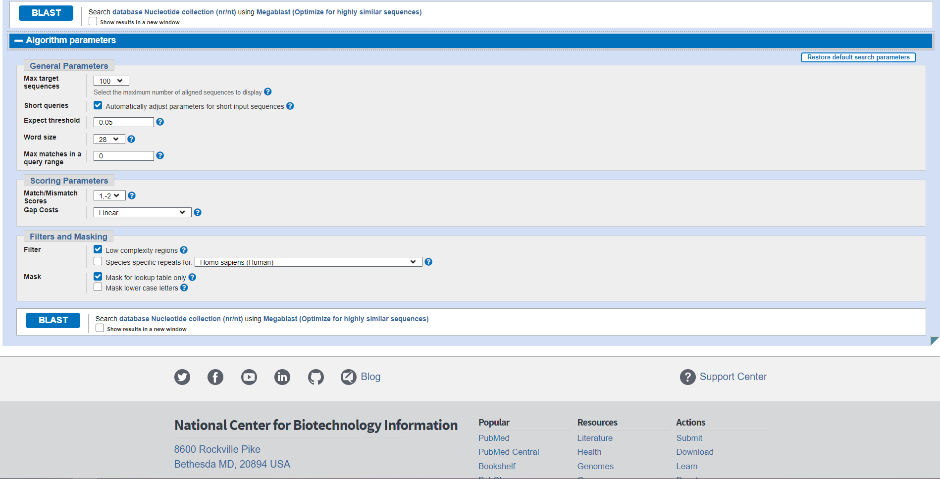Fig4. Algorithm parameters in blastn

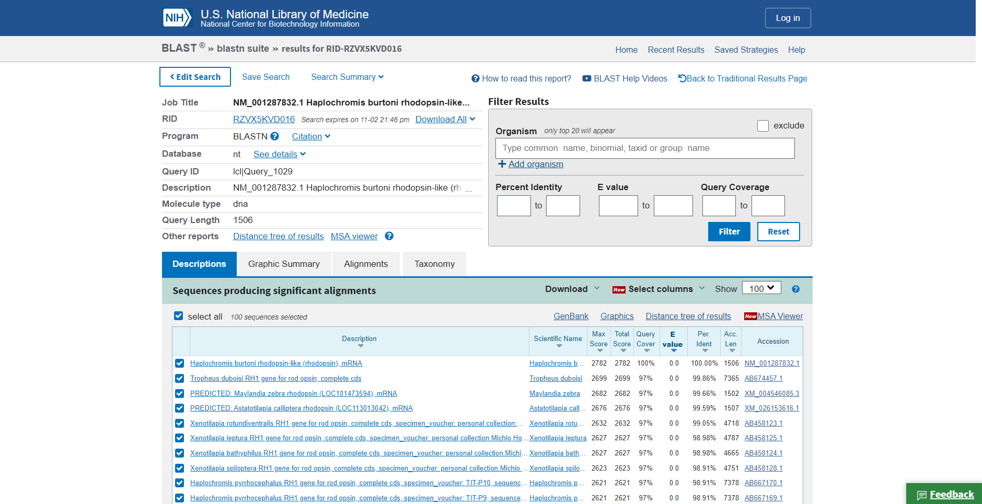Fig5. Result page (header file) for Rhodopsin.

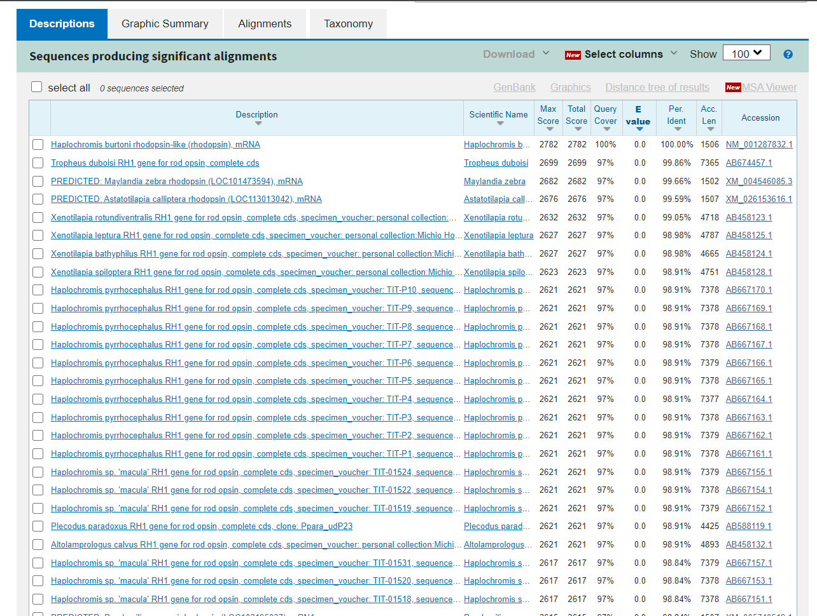Fig6. Description for query Rhodopsin

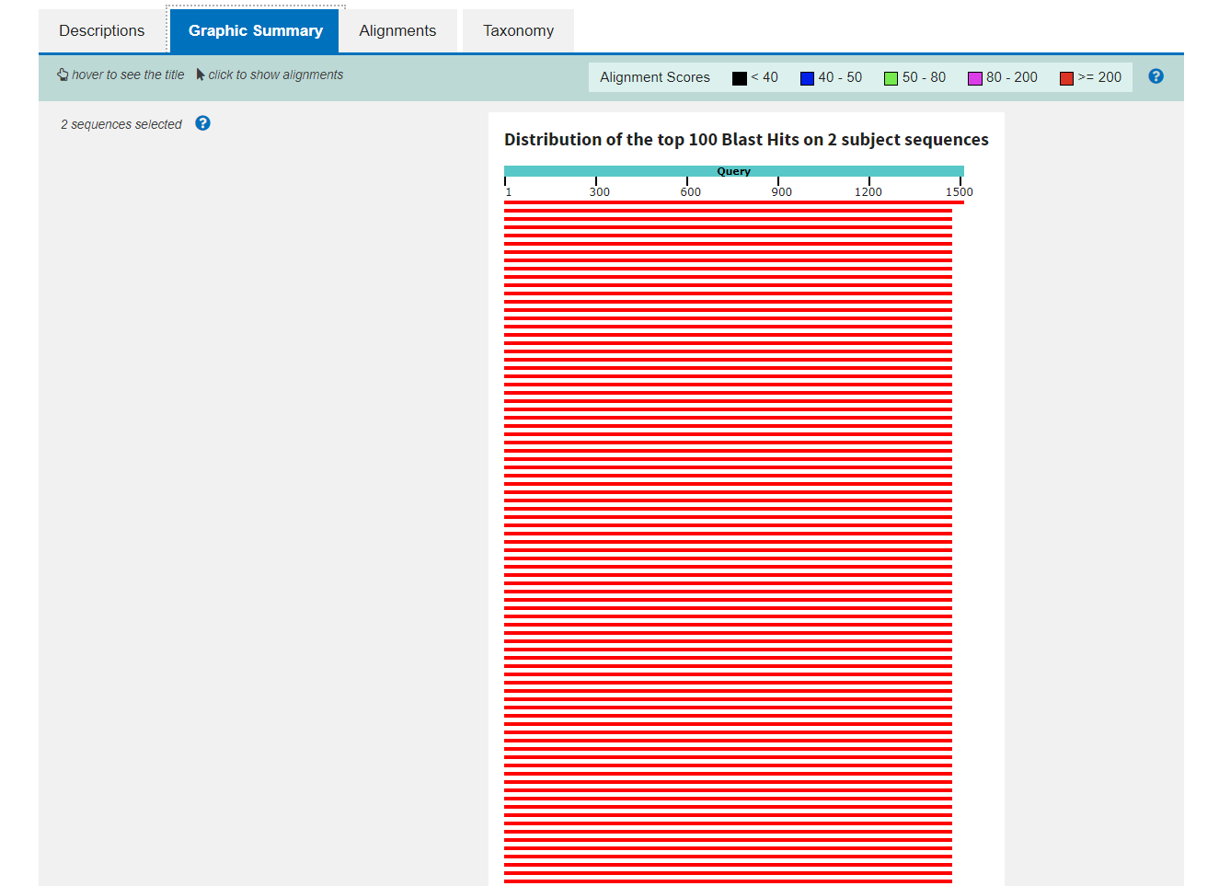Fig7. Graphic Summary for query Rhodopsin

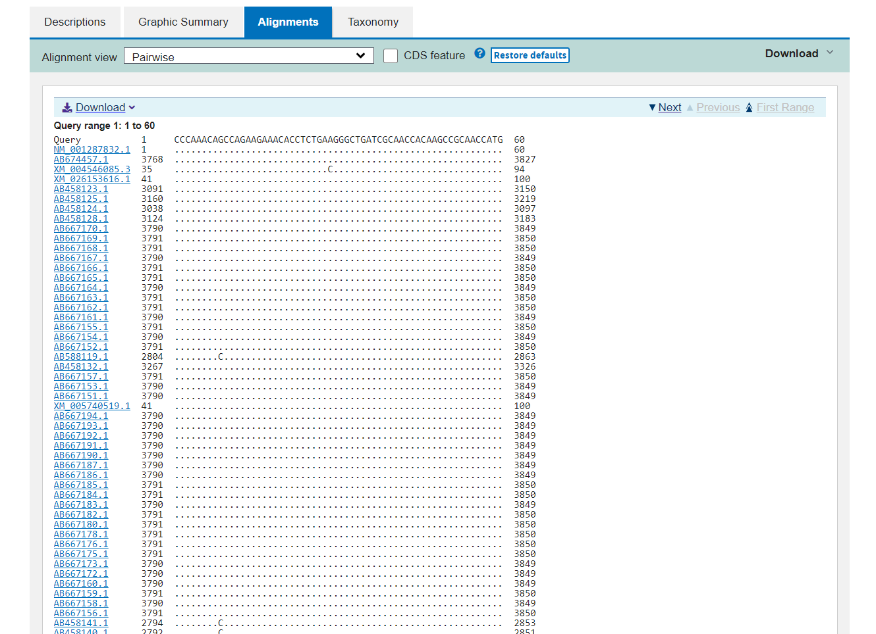Fig8. Alignment for query Rhodopsin

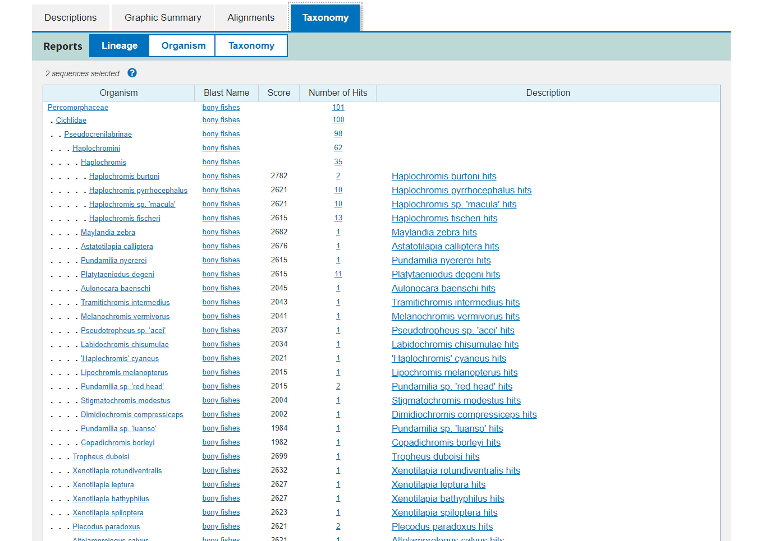Fig9. Taxonomy for query Rhodopsin

Results:
Here we have acquired info about the descriptions, Graphical summary, Alignment, and taxonomy related information on our query rhodopsin.

The results can be interpreted as:

Maximum score is the highest alignment score between the query sequence and the database segments.
Total score is the sum of the alignment scores of all sequences from the same db.
Percent Query coverage is the percent of the query length that is included in the aligned segments.
E-value is the measure of likeliness that sequence similarity is not random chance percent identity describes how similar the query is to the aligned sequences.

Conclusion:
BLASTN is a great tool to get the required information on a particular FASTA sequence in detail.

References:
- BLAST: Basic Local Alignment Search Tool. (n.d.). Retrieved from https://blast.ncbi.nlm.nih.gov/Blast.cgi
- BLAST: Basic Local Alignment Search Tool. (n.d.). Retrieved from https://blast.ncbi.nlm.nih.gov/Blast.cgi#alnHdr_2
- Nucleotide BLAST: Search nucleotide databases using a nucleotide query. (n.d.). Retrieved from https://blast.ncbi.nlm.nih.gov/Blast.cgi?PROGRAM=blastn&PAGE_TYPE=BlastSearch&LINK_LOC=blasthome
- Haplochromis burtoni rhodopsin-like (rhodopsin), mRNA - Nucleotide - NCBI. (n.d.). Retrieved from https://www.ncbi.nlm.nih.gov/nuccore/NM_001287832.1?report=fasta

Date: 1-11-21
WEBLEM 11/b
(URL: https://blast.ncbi.nlm.nih.gov/Blast.cgi)

Aim:
To study the Query ‘Rhodopsin’ in BLASTp

Introduction:
A sequences similarity search often provides the first information about a new DNA or protein sequence. A search allows scientists to infer the function of a sequence from similar sequence. There are many ways of performing a sequences similarity search, but probably the most popular method is the “Basic Local Alignment Search Tools” (BLAST). BLAST uses heuristics to produces result quickly. It also calculates an “expect value” that estimates how many matches would have occurred at a given score by chance, which can aid a user in judging how much confidence to have in an alignment.
- BLASTP performs protein-protein sequence comparison, and its algorithm is the basis of many other types of BLAST searches such as BLASTX and TBLASTN.

Rhodopsin, also called visual purple, pigment-containing sensory protein that converts light into an electrical signal. Rhodopsin is found in a wide range of organisms, from vertebrates to bacteria. In many seeing animals, including humans, it is required for vision in dim light and is located in the retina of the eye specifically, within the tightly packed disks that make up the outer segment of the retina’s photoreceptive rod cells, which are specially adapted for vision under low-light conditions.

Rhodopsin was discovered in 1876 by German physiologist Franz Christian Boll, who observed that the normally reddish purple frog retina turned pale in bright light. The fading of colour was later attributed to the destruction of rhodopsin, via a process known as bleaching. Bleaching and the subsequent regeneration of rhodopsin are major steps in the visual cycle—the series of biochemical reactions that is critical for vision in low light.

Methodology:
- Open the homepage of blast.
- After that click the Blastp.
- Enter the sequence for rhodopsin taken from uniport
- Open the result page.
- Interpret the result.

Observation:
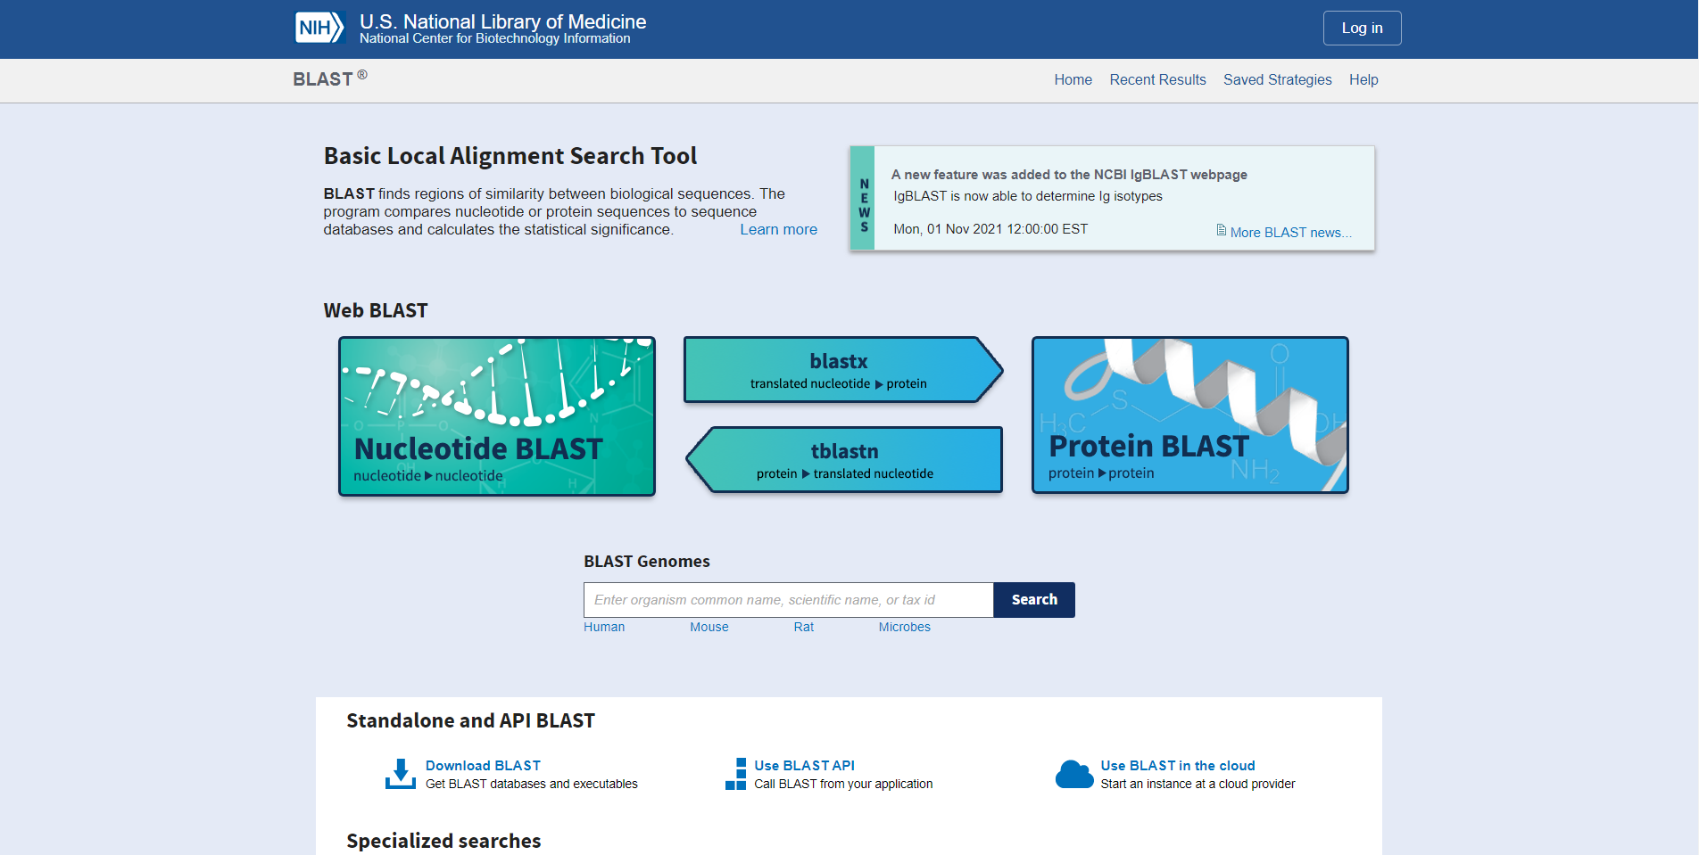Fig1. Home page of BLAST

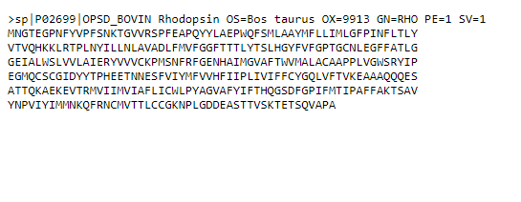Fig2. Fasta Sequence for query rhodopsin taken from uniport

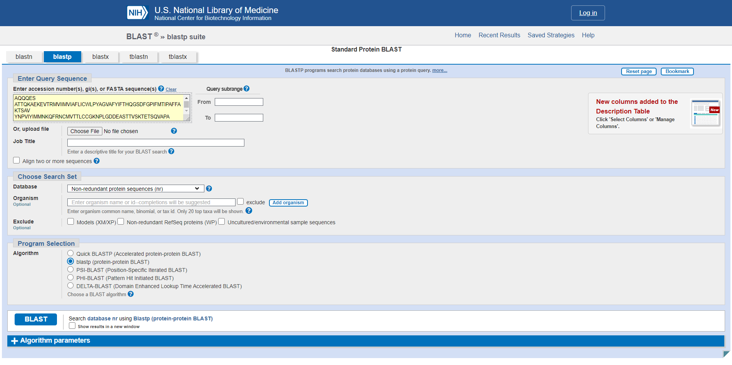Fig3. Search page for blastp with sequence.

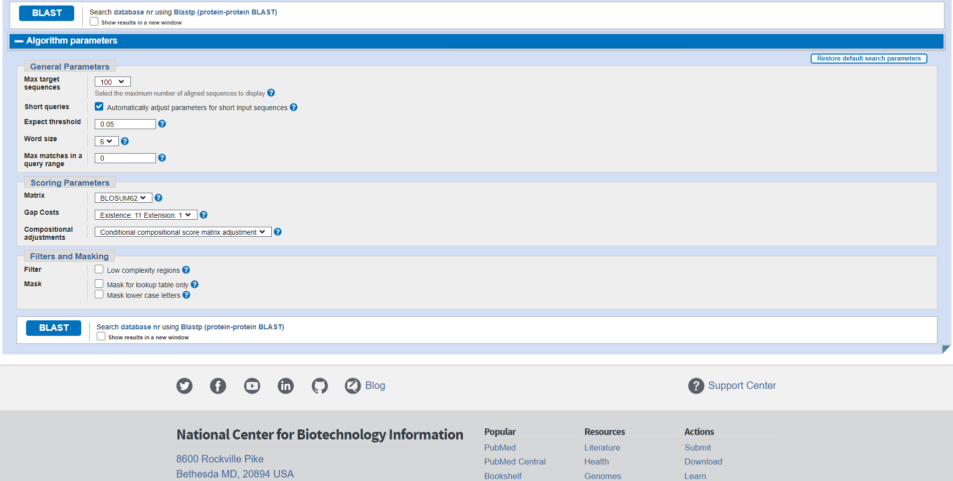Fig4. Algorithm parameters in BLASTP

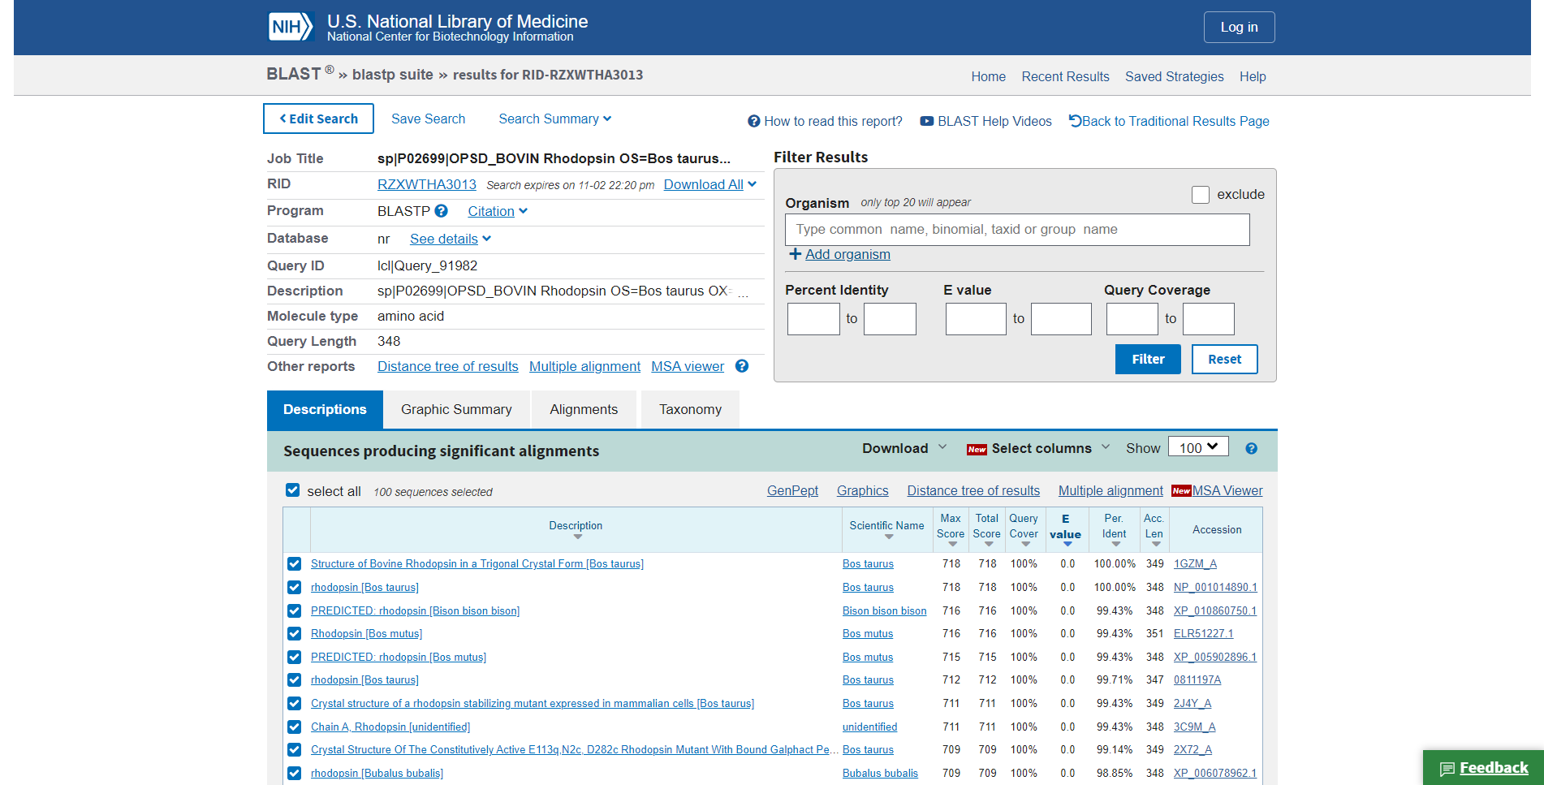Fig5. Result page for rhodopsin

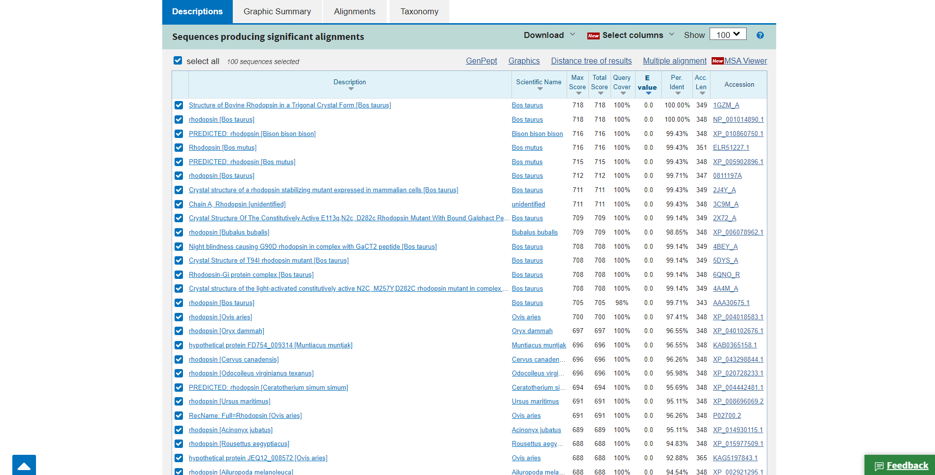Fig6. Description for query Rhodopsin

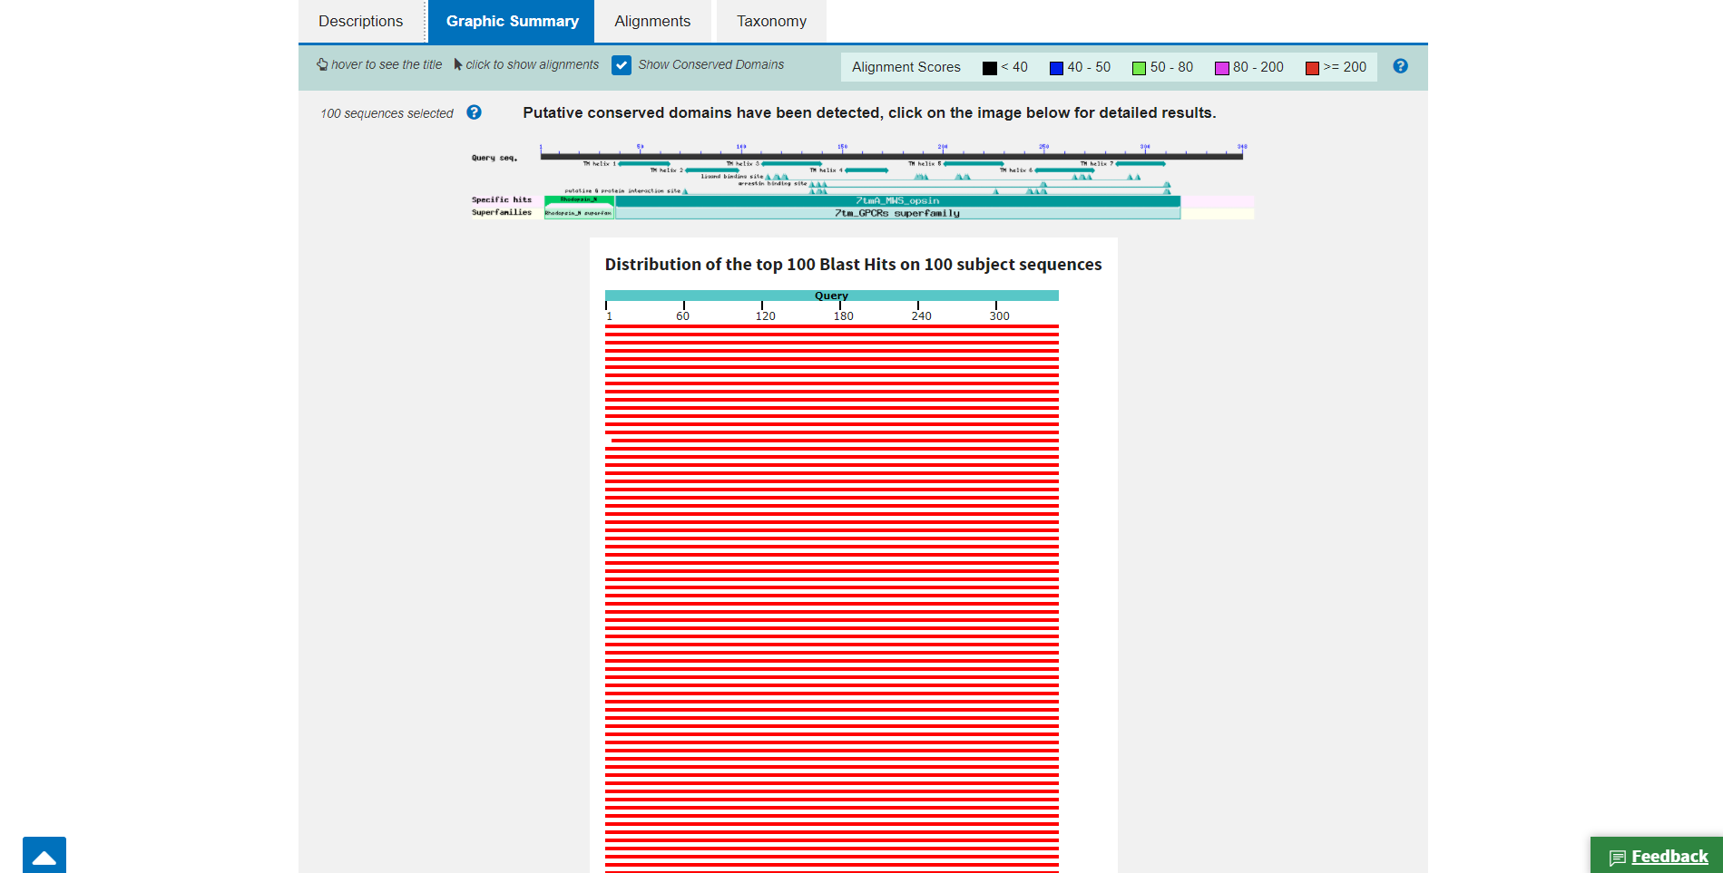Fig7. Graphic Summary for query rhodopsin

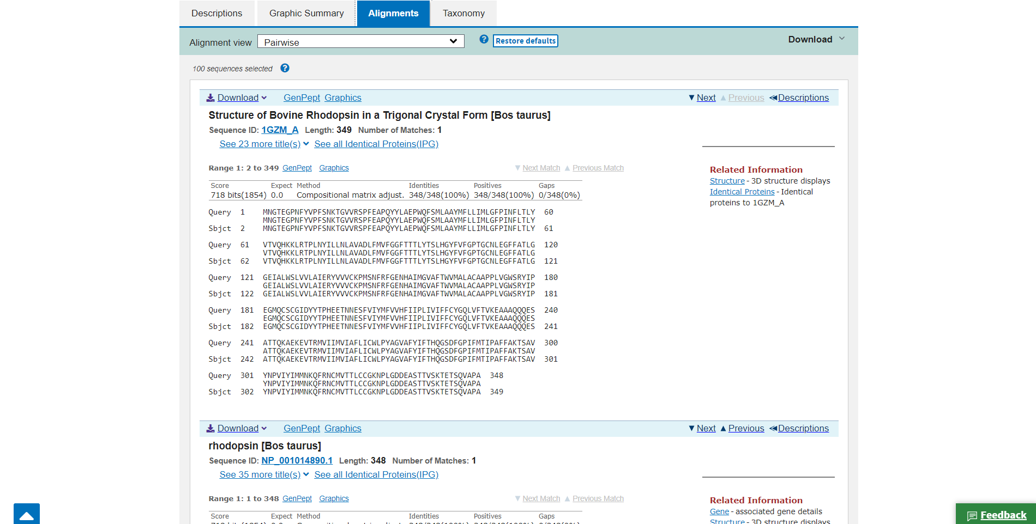Fig8. Alignment for query rhodopsin

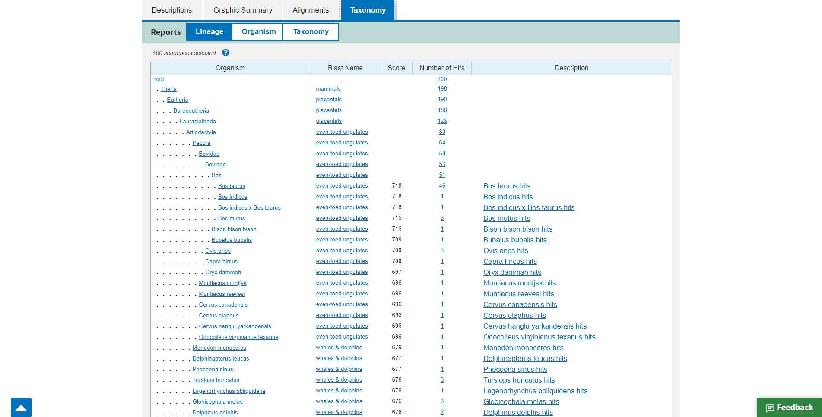Fig9. Taxonomy for query rhodopsin

Results:
Here we have acquired info about the descriptions, Graphical summary, Alignment, and taxonomy related information on our query rhodopsin.

The results can be interpreted as:

Maximum score is the highest alignment score between the query sequence and the database segments.
Total score is the sum of the alignment scores of all sequences from the same db.
Percent Query coverage is the percent of the query length that is included in the aligned segments.
E-value is the measure of likeliness that sequence similarity is not random chance percent identity describes how similar the query is to the aligned sequences.

Conclusion:
BLASTN is a great tool to get the required information on a particular FASTA sequence in detail.

References:
- (n.d.). Retrieved from https://www.uniprot.org/uniprot/P02699.fasta
- BLAST: Basic Local Alignment Search Tool. (n.d.). Retrieved from https://blast.ncbi.nlm.nih.gov/Blast.cgi
- Protein BLAST: Search protein databases using a protein query. (n.d.). Retrieved from https://blast.ncbi.nlm.nih.gov/Blast.cgi?PROGRAM=blastp&PAGE_TYPE=BlastSearch&LINK_LOC=blasthome
- Rhodopsin. (n.d.). Retrieved from https://www.britannica.com/science/rhodopsin

DATE: 1-11-21
WEBLEM 11/c
(URL: https://www.ebi.ac.uk/Tools/sss/fasta/)

Aim:
To study the Query ‘Rhodopsin’ in FASTAn

Introduction:
FASTA (pronounced FAST-AYE) is a suite of programs for searching nucleotide or protein databases with a query sequence. FASTA itself performs a local heuristic search of a protein or nucleotide database for a query of the same type. FASTX and FASTY translate a nucleotide query for searching a protein database. TFASTX and TFASTY translate a nucleotide database to be searched with a protein query. Optimal searches are available with the programs SSEARCH (local), GGSEARCH (global) and GLSEARCH (global query against local database).
FASTAn:
This tool provides sequence similarity searching against nucleotide databases using the FASTA suite of programs. FASTA provides a heuristic search with a nucleotide query. TFASTX and TFASTY translate the DNA database for searching with a protein query. Optimal searches are available with SSEARCH (local), GGSEARCH (global) and GLSEARCH (global query, local database).

Rhodopsin, also called visual purple, pigment-containing sensory protein that converts light into an electrical signal. Rhodopsin is found in a wide range of organisms, from vertebrates to bacteria. In many seeing animals, including humans, it is required for vision in dim light and is located in the retina of the eye specifically, within the tightly packed disks that make up the outer segment of the retina’s photoreceptive rod cells, which are specially adapted for vision under low-light conditions.

Rhodopsin was discovered in 1876 by German physiologist Franz Christian Boll, who observed that the normally reddish purple frog retina turned pale in bright light. The fading of colour was later attributed to the destruction of rhodopsin, via a process known as bleaching. Bleaching and the subsequent regeneration of rhodopsin are major steps in the visual cycle—the series of biochemical reactions that is critical for vision in low light.

Methodology:
- Open the homepage of FASTA.
- After that click the FASTAn hyperlink
- Enter the sequence for keratin taken by Genebank.
- Open the result page.
- Interpret the results.

Observation:
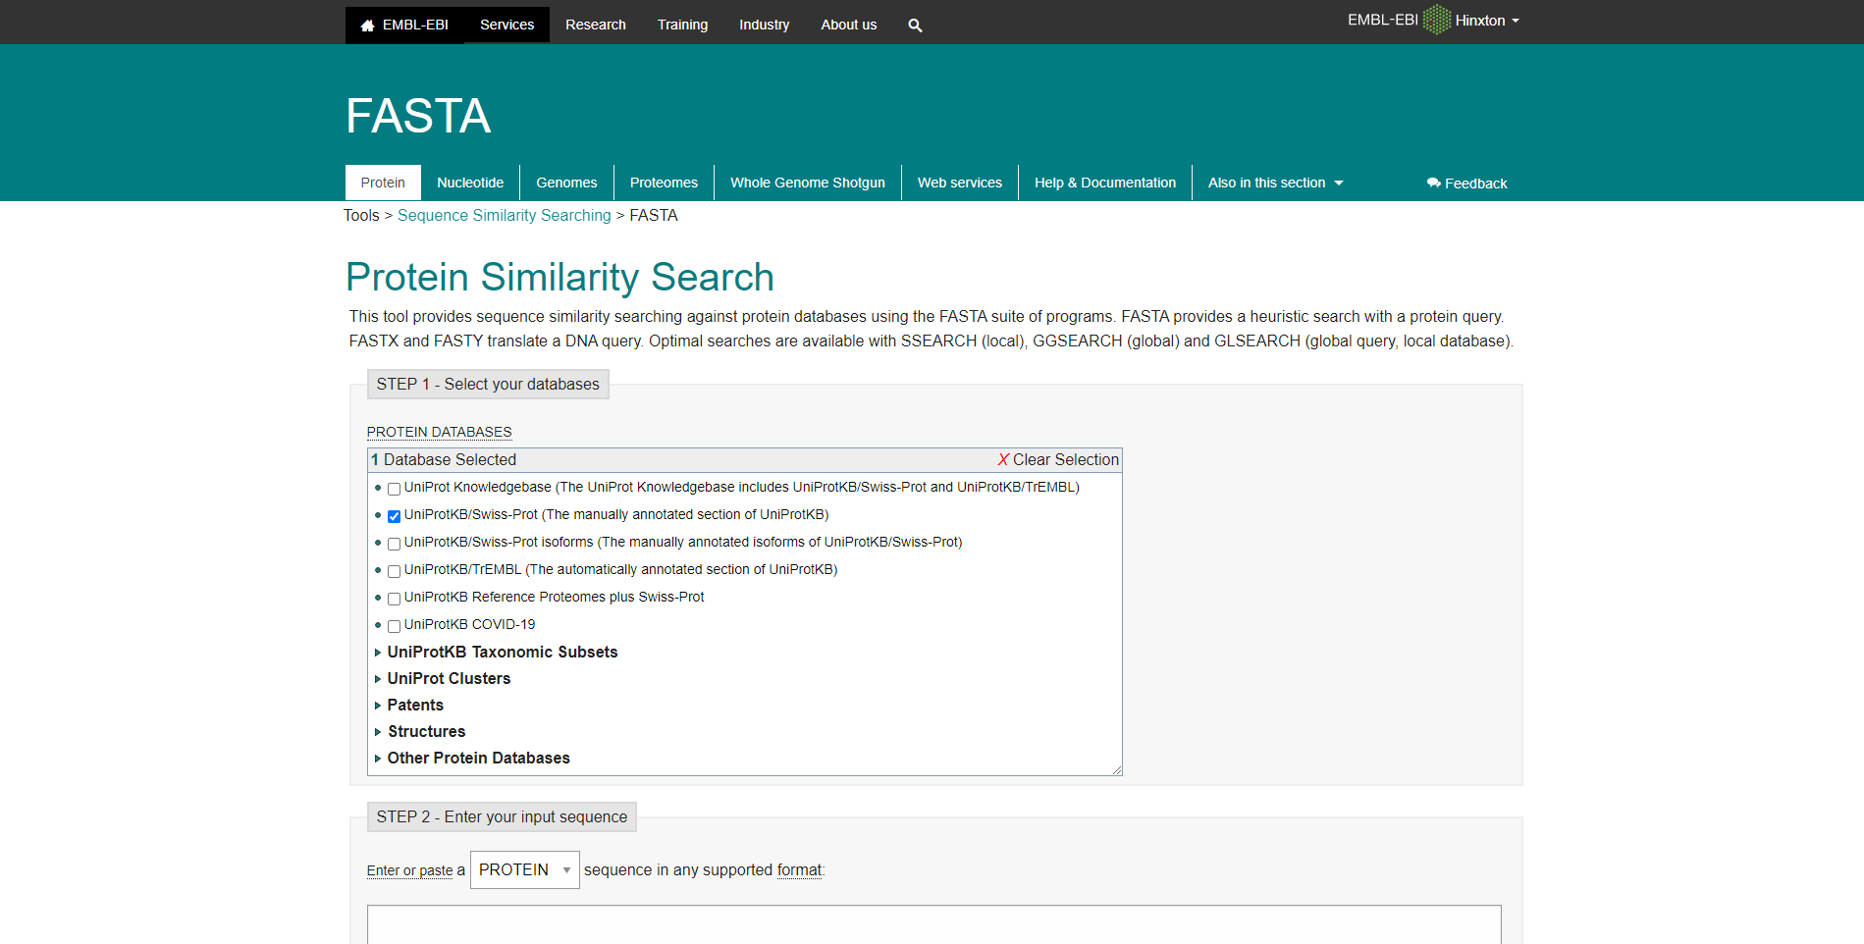Fig1. Homepage of FASTAn.

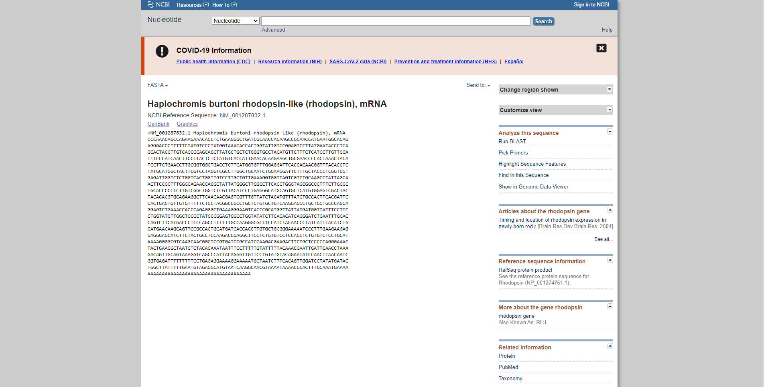Fig2. Fasta sequence for my quesry rhodopsin on genbank

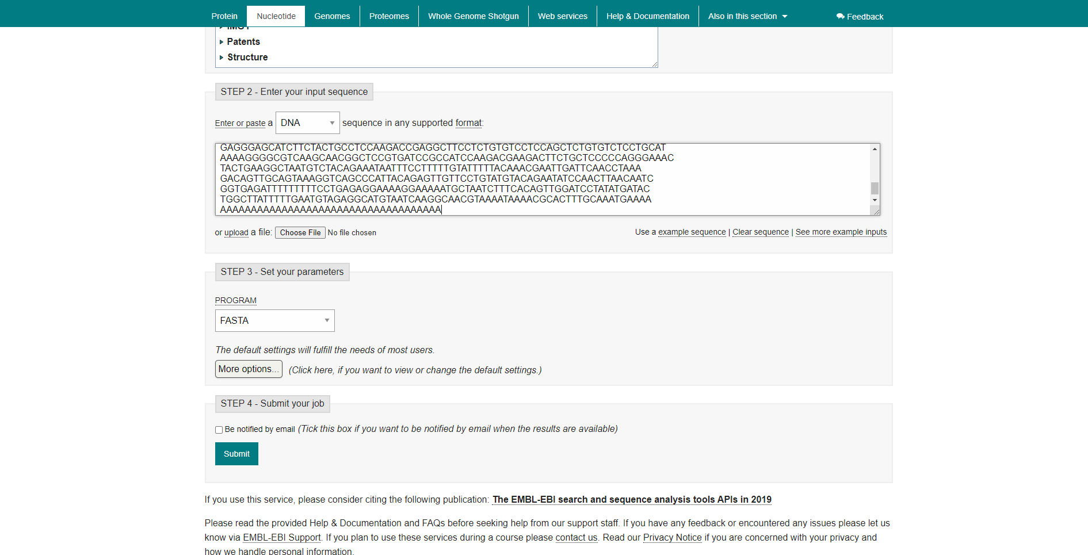Fig3. Search bar of FASTAn with sequence.

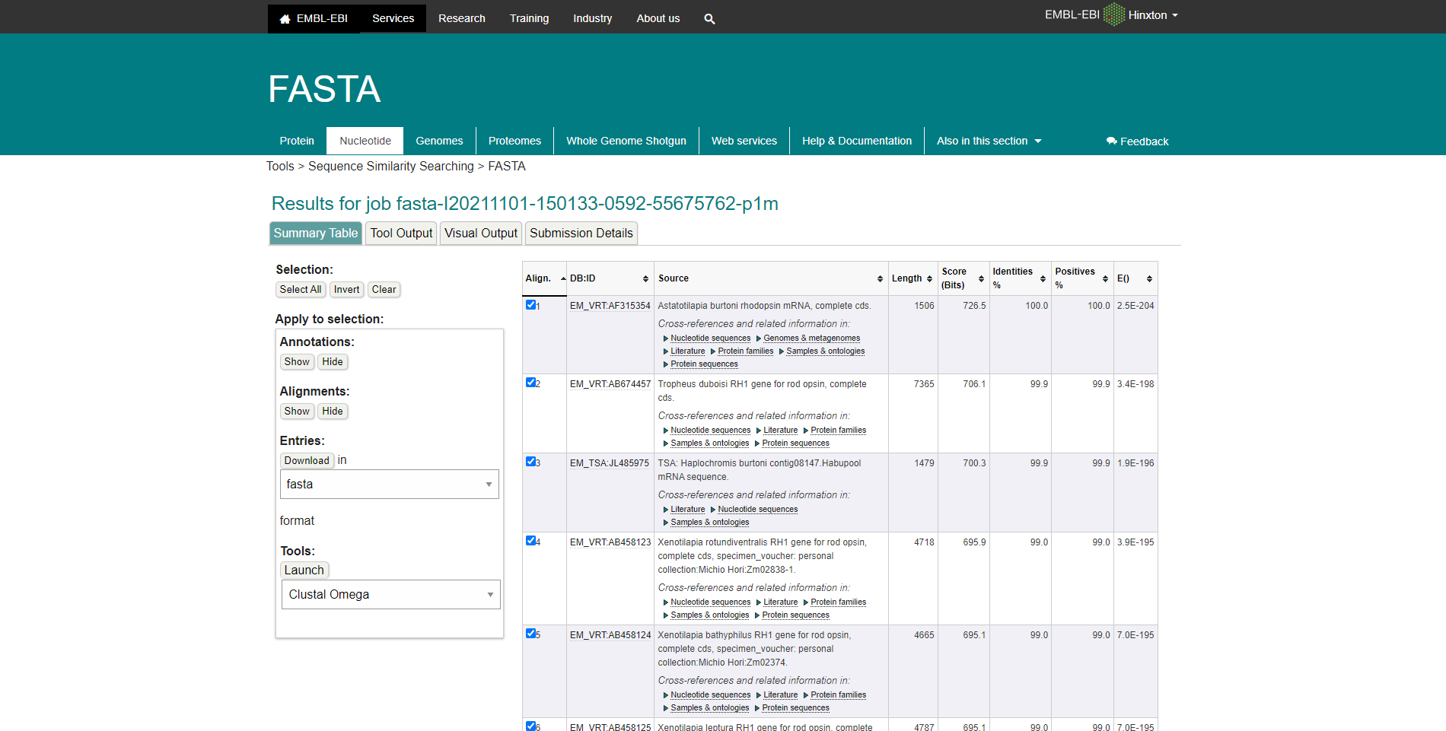Fig4. Summary table for FASTAn with sequence

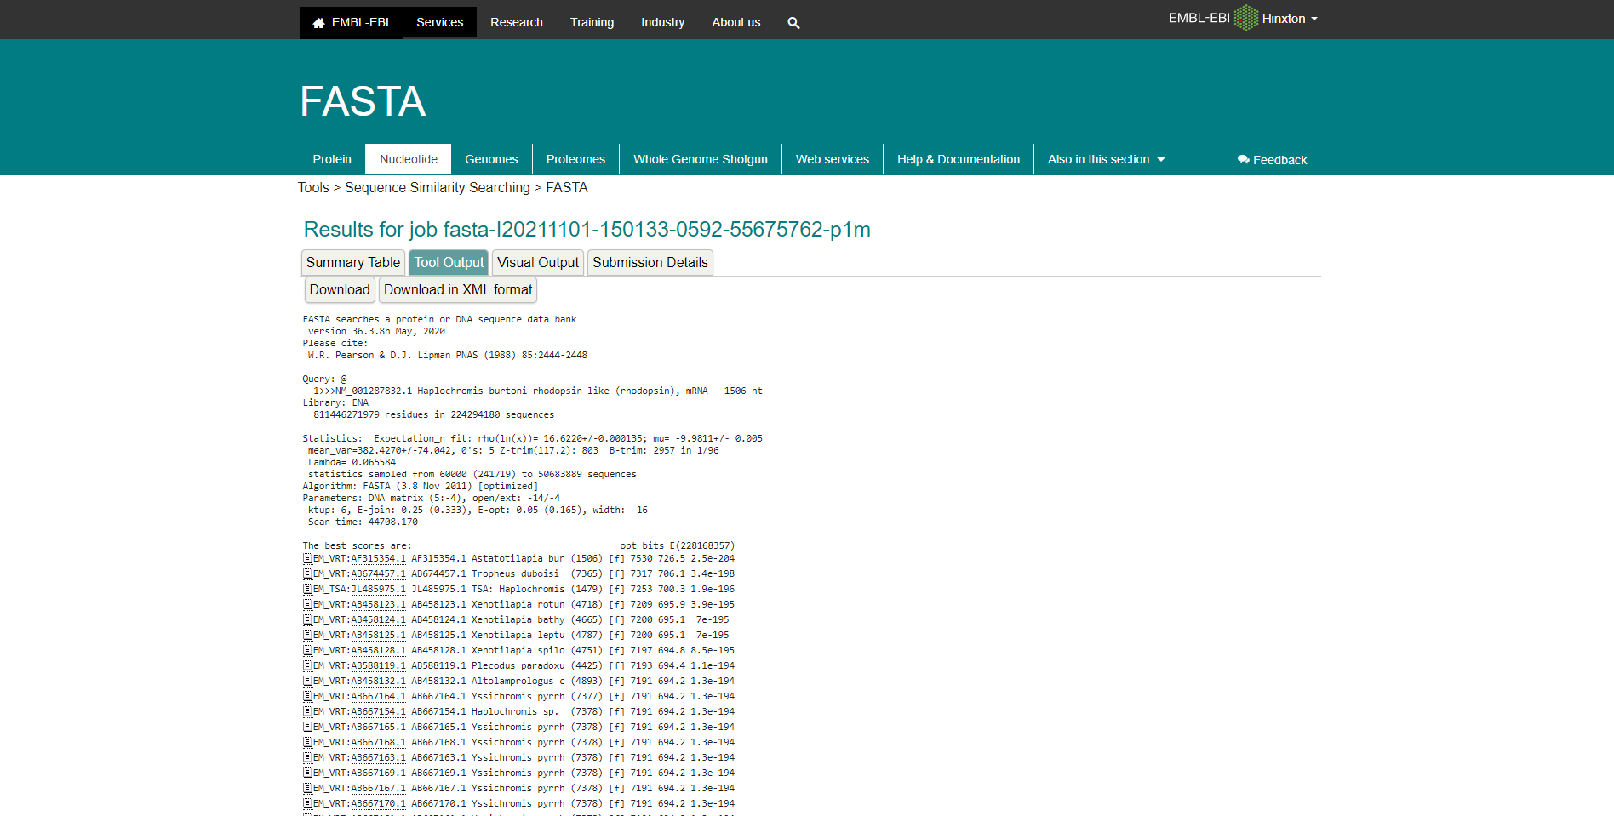Fig5. Tool output for Rhodopsin in FASTAn

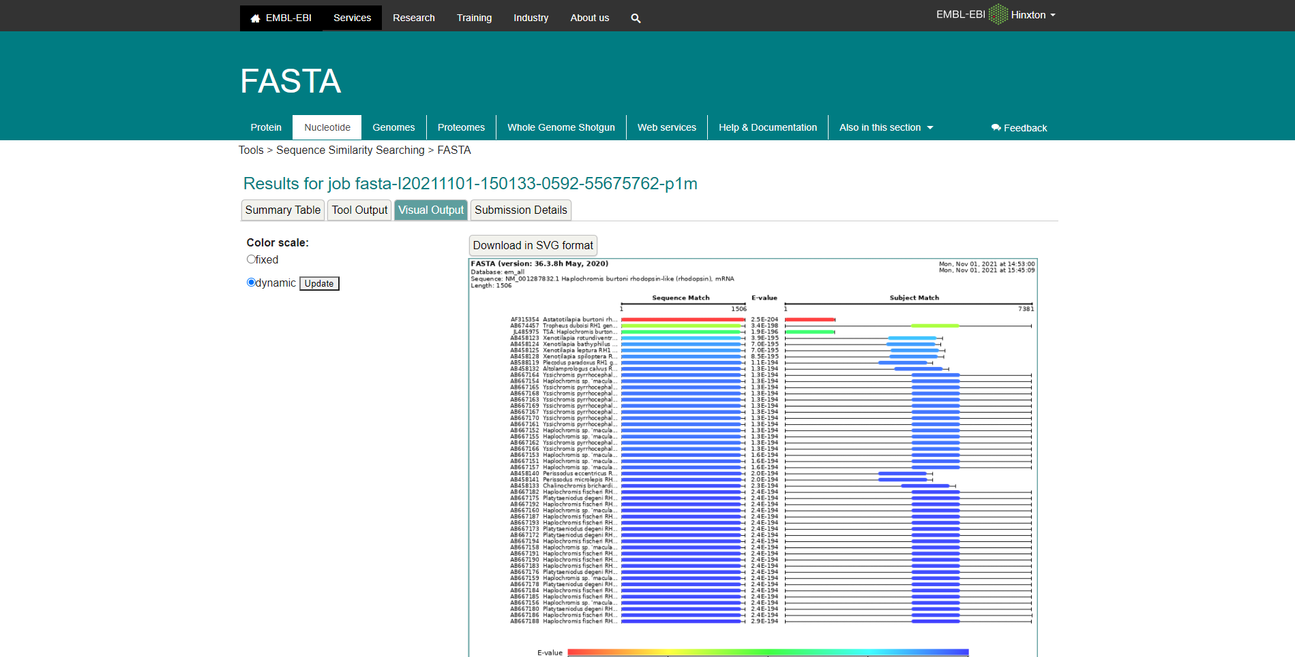Fig6. Visual output for Rhodopsin in FASTAn

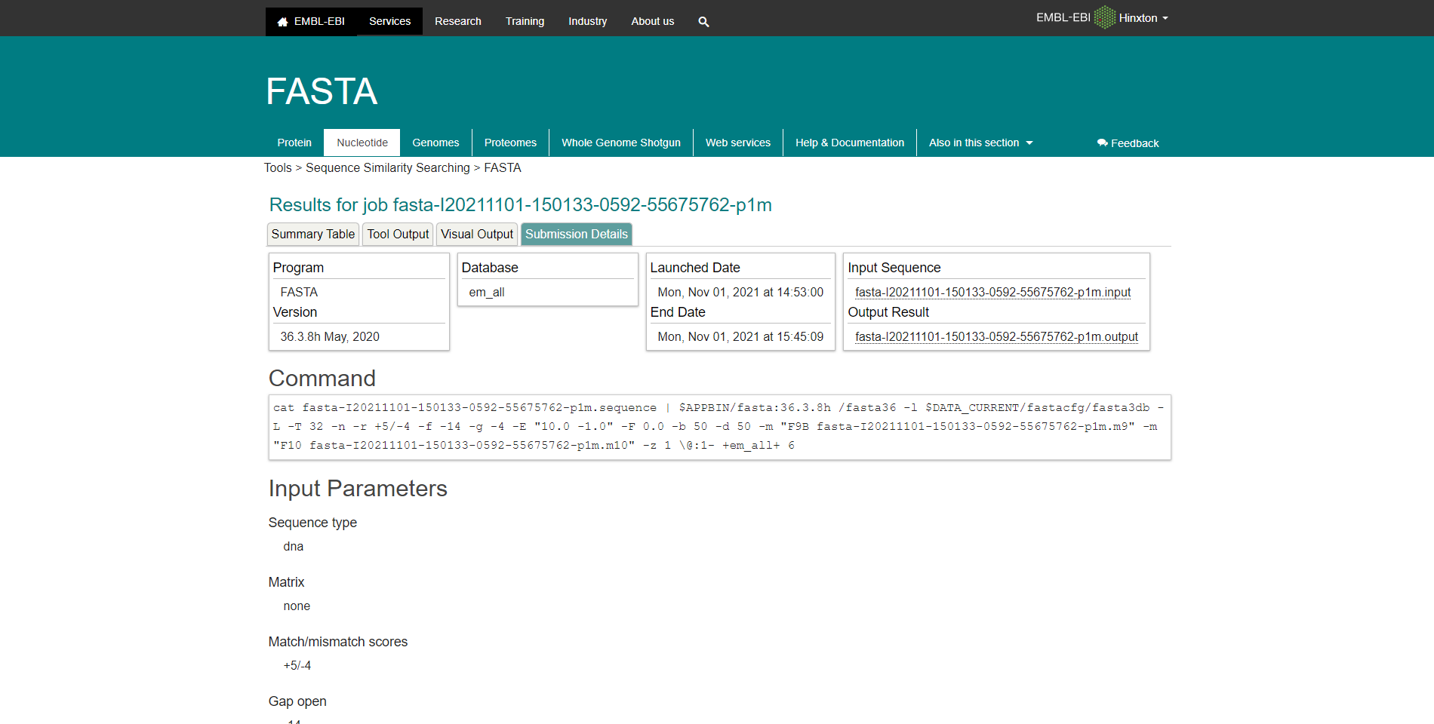Fig7. Submission details for Rhodopsin in FASTAn

Results:
FASTAp Result divided into 5 sections summary tables, Tool output, visual output, functional predictions, Submission details.

In summary tables it shows alignment of sequence that is length, score bits, identity percentage and positive percentage.

Tools output for keratin in FASTAp shows multiple outputs for results

In visual output the color scale can be changed between fixed and dynamic, showing E-Values

Functional Prediction’s color scale can also be switched between dynamic and fixed, showing E-Values

The submission details shows use the commands and input parameters that were used before we submitted the query for running.

Conclusion:
FASTA is another sequence alignment tool which is used to search similarities between sequences of DNA and proteins. The query sequence is broken down into sequence patterns or words known as k-tuples and the target sequences are searched for these k-tuples in order to find the similarities between the two.

References:
- Rhodopsin. (n.d.). Retrieved from https://www.britannica.com/science/rhodopsin
- (n.d.). Retrieved from https://www.uniprot.org/uniprot/P02699.fasta
- Embl-Ebi. (n.d.). FASTA. Retrieved from https://www.ebi.ac.uk/Tools/sss/fasta/
- Embl-Ebi. (n.d.). FASTA. Retrieved from https://www.ebi.ac.uk/Tools/services/web/toolresult.ebi?jobId=fasta-I20211101-150915-0959-51807210-p2m

DATE: 1-11-21
WEBLEM 11/d
(URL: https://www.ebi.ac.uk/Tools/sss/fasta/)

Aim:
To study the Query ‘Rhodopsin’ in FASTAp.

Introduction:
FASTA (pronounced FAST-AYE) is a suite of programs for searching nucleotide or protein databases with a query sequence. FASTA itself performs a local heuristic search of a protein or nucleotide database for a query of the same type. FASTX and FASTY translate a nucleotide query for searching a protein database. TFASTX and TFASTY translate a nucleotide database to be searched with a protein query. Optimal searches are available with the programs SSEARCH (local), GGSEARCH (global) and GLSEARCH (global query against local database).
FASTAp:
This tool provides sequence similarity searching against protein databases using the FASTA suite of programs. FASTA provides a heuristic search with a protein query. FASTX and FASTY translate a DNA query. Optimal searches are available with SSEARCH (local), GGSEARCH (global) and GLSEARCH (global query, local database).

Rhodopsin, also called visual purple, pigment-containing sensory protein that converts light into an electrical signal. Rhodopsin is found in a wide range of organisms, from vertebrates to bacteria. In many seeing animals, including humans, it is required for vision in dim light and is located in the retina of the eye specifically, within the tightly packed disks that make up the outer segment of the retina’s photoreceptive rod cells, which are specially adapted for vision under low-light conditions.

Rhodopsin was discovered in 1876 by German physiologist Franz Christian Boll, who observed that the normally reddish purple frog retina turned pale in bright light. The fading of colour was later attributed to the destruction of rhodopsin, via a process known as bleaching. Bleaching and the subsequent regeneration of rhodopsin are major steps in the visual cycle—the series of biochemical reactions that is critical for vision in low light.

Methodology:
- Open the homepage of FASTA
- Click on the FASTAp hyperlink
- Enter the sequence for keratin taken by uniport
- Open the result page.
- Interpret the result.

Observation:
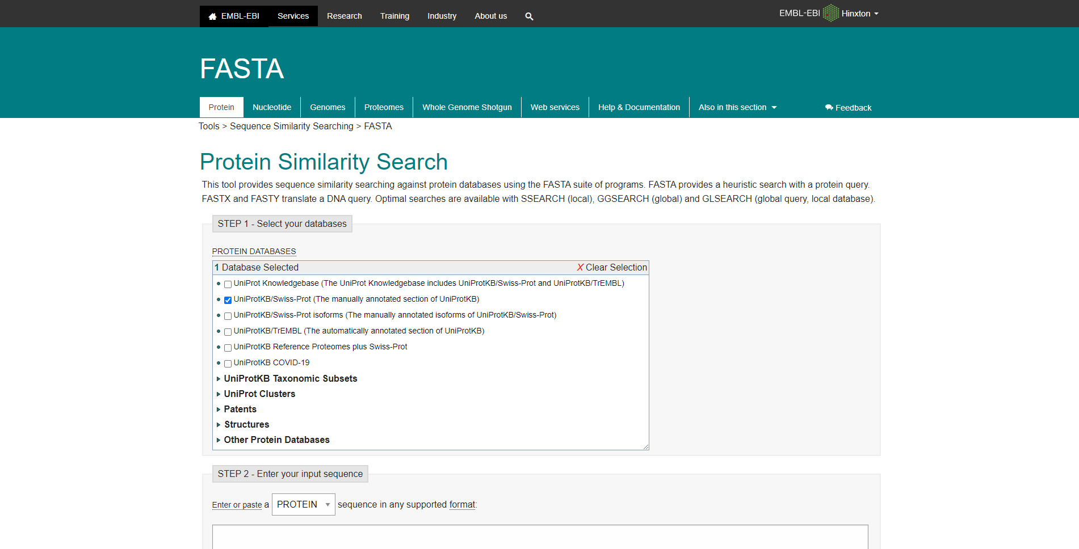Fig1. Homepage of FASTAp

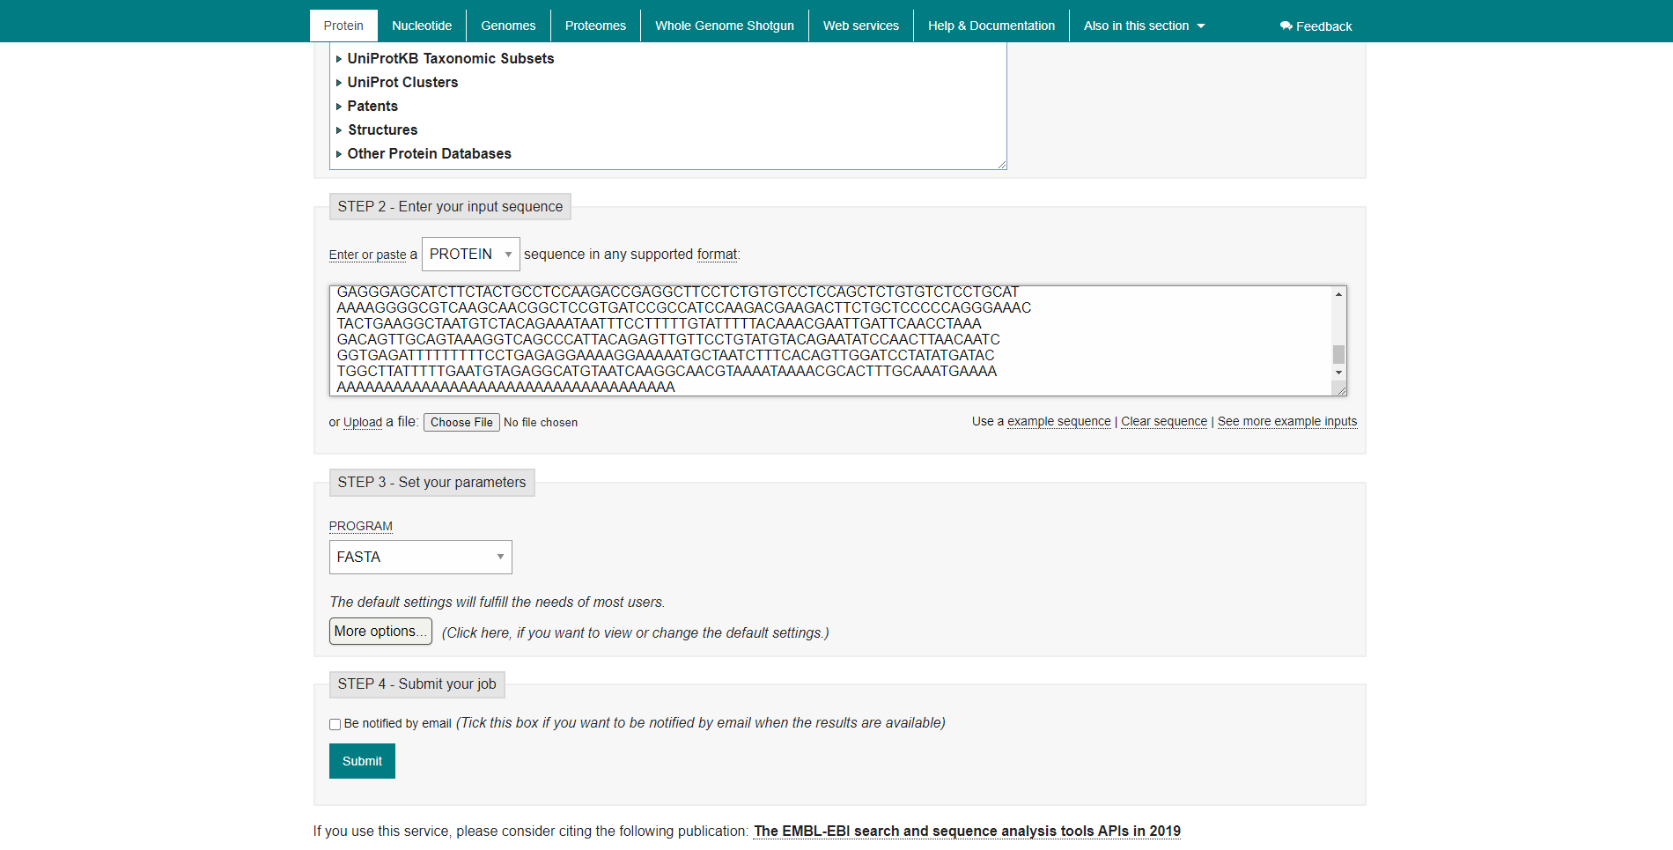Fig2. Search bar for FASTAp with sequence for rhodopsin taken from uniprot

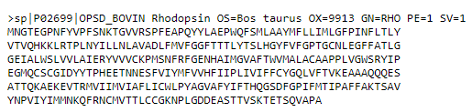Fig3. Fasta sequence for my query Rhodopsin

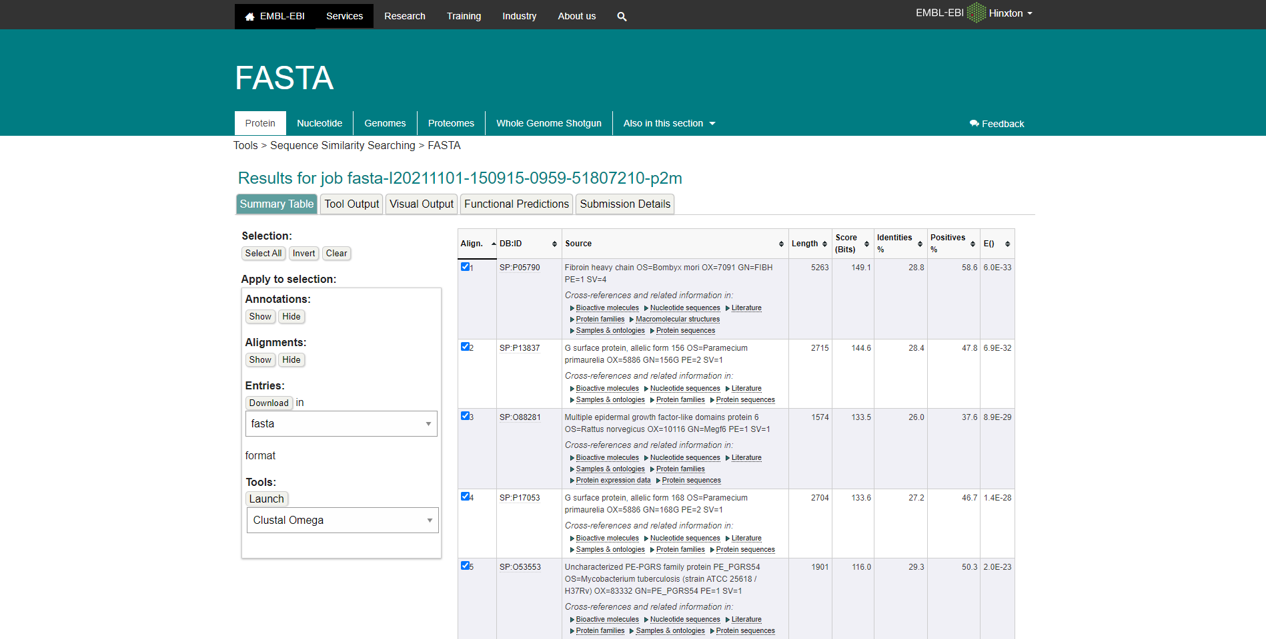Fig4. Summary table for Rhodopsin in FASTAp

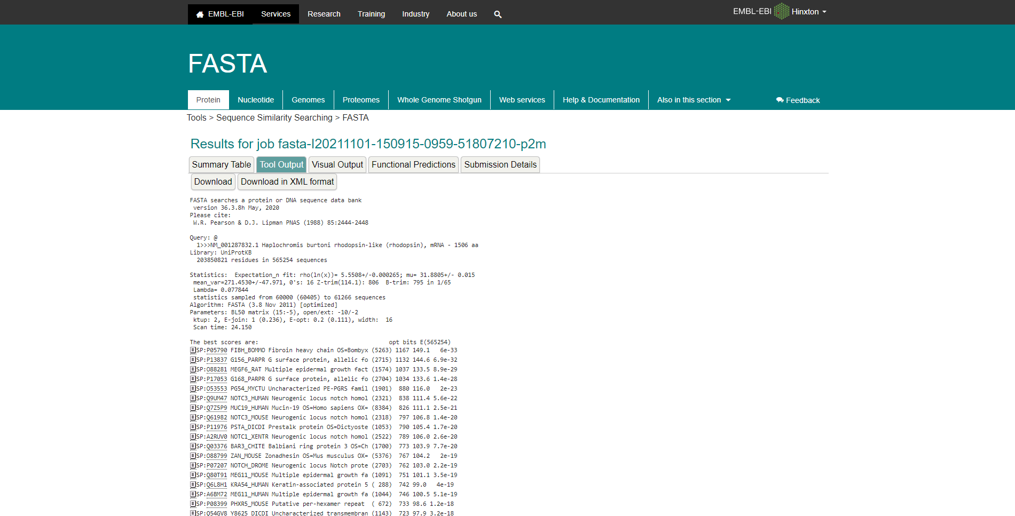Fig5. Tool Output for Rhodopsin in FASTAp.

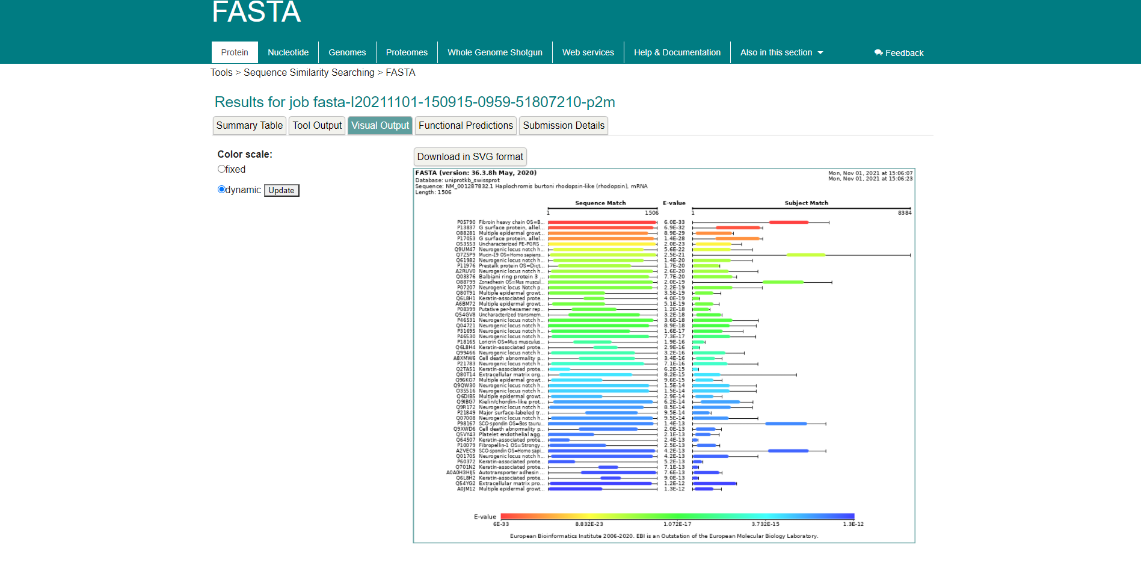Fig6. Visual output for Rhodopsin in FASTAp

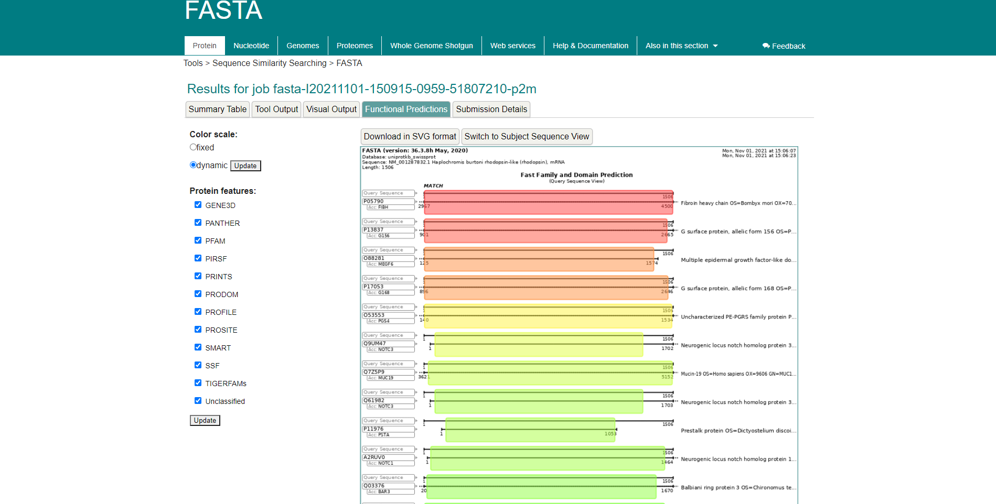Fig7. Functional Predictions for Rhodopsin in FASTAp

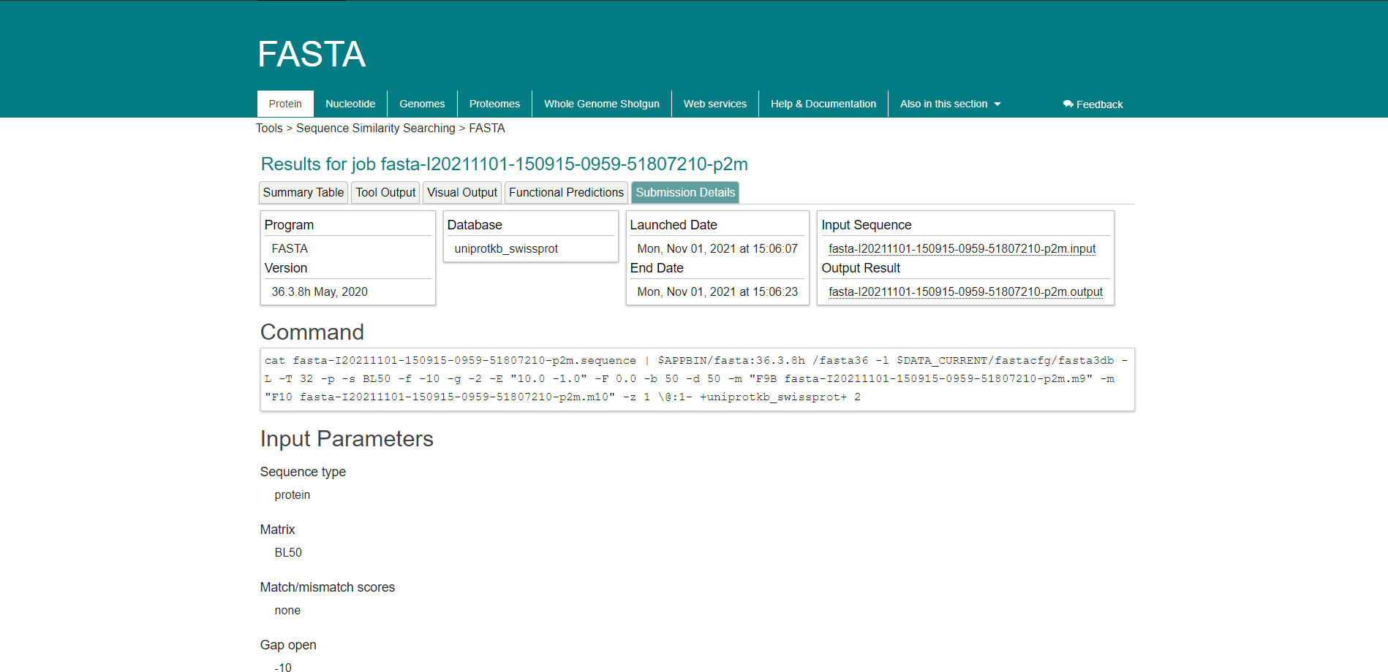Fig8. Submission Details for Rhodopsin in FASTAp

Results:
FASTAp Result divided into 5 sections summary tables, Tool output, visual output, functional predictions, Submission details.

In summary tables it shows alignment of sequence that is length, score bits, identity percentage and positive percentage.

Tools output for keratin in FASTAp shows multiple outputs for results

In visual output the color scale can be changed between fixed and dynamic, showing E-Values

Functional Prediction’s color scale can also be switched between dynamic and fixed, showing E-Values

The submission details shows use the commands and input parameters that were used before we submitted the query for running.

Conclusion:
FASTA is another sequence alignment tool which is used to search similarities between sequences of DNA and proteins. The query sequence is broken down into sequence patterns or words known as k-tuples and the target sequences are searched for these k-tuples in order to find the similarities between the two.

References:
- Rhodopsin. (n.d.). Retrieved from https://www.britannica.com/science/rhodopsin
- (n.d.). Retrieved from https://www.uniprot.org/uniprot/P02699.fasta
- Embl-Ebi. (n.d.). FASTA. Retrieved from https://www.ebi.ac.uk/Tools/sss/fasta/
- Embl-Ebi. (n.d.). FASTA. Retrieved from https://www.ebi.ac.uk/Tools/services/web/toolresult.ebi?jobId=fasta-I20211101-150915-0959-51807210-p2m

DATE: 1-11-21
WEBLEM 11/e
(URL: https://blast.ncbi.nlm.nih.gov/Blast.cgi)

Aim:
To study the Query ‘Rhodopsin’ in PHI BLAST

Introduction:
A sequence similarity search often provides the first information about a new DNA or protein sequence. A search allows scientists to infer the function of a sequence from similar sequences. There are many ways of performing a sequence similarity search, but probably the most popular method is the “Basic Local Alignment Search Tool” (BLAST) (1, 2). BLAST uses heuristics to produce results quickly. It also calculates an “expect value” that estimates how many matches would have occurred at a given score by chance, which can aid a user in judging how much confidence to have in an alignment.

PHI-BLAST (Pattern-Hit Initiated BLAST) is a search program that combines matching of regular expressions with local alignments surrounding the match. The most important features of the program have been incorporated into the BLAST software framework partly for user convenience and partly so that PHI-BLAST may be combined seamlessly with PSI-BLAST. Other features that do not fit into the BLAST framework will be released later as a separate program and/or separate Web page query options. One very restrictive way to identify protein motifs is by regular expressions that must contain each instance of the motif. The PROSITE database is a compilation of restricted regular expressions that describe protein motifs. Given a protein sequence S and a regular expression pattern P occurring in S, PHI-BLAST helps answer the question: What other protein sequences both contain an occurrence of P and are homologous to S in the vicinity of the pattern occurrences? PHI-BLAST may be preferable to just searching for pattern occurrences because it filters out those cases where the pattern occurrence is probably random and not indicative of homology. PHI-BLAST may be preferable to other flavors of BLAST because it is faster and because it allows the user to express a rigid pattern occurrence requirement.

Rhodopsin, also called visual purple, pigment-containing sensory protein that converts light into an electrical signal. Rhodopsin is found in a wide range of organisms, from vertebrates to bacteria. In many seeing animals, including humans, it is required for vision in dim light and is located in the retina of the eye specifically, within the tightly packed disks that make up the outer segment of the retina’s photoreceptive rod cells, which are specially adapted for vision under low-light conditions. Rhodopsin was discovered in 1876 by German physiologist Franz Christian Boll, who observed that the normally reddish purple frog retina turned pale in bright light. The fading of colour was later attributed to the destruction of rhodopsin, via a process known as bleaching. Bleaching and the subsequent regeneration of rhodopsin are major steps in the visual cycle—the series of biochemical reactions that is critical for vision in low light.

Methodology:
- Open the homepage of blast.
- After that click the BLASTp
- Enter the sequence for rhodopsin taken by uniport.
- Change the program selection Algorithm to PHI-BLAST
- Enter the pattern taken by prosite
- Open the result page
- Interpret the result.

Observation:
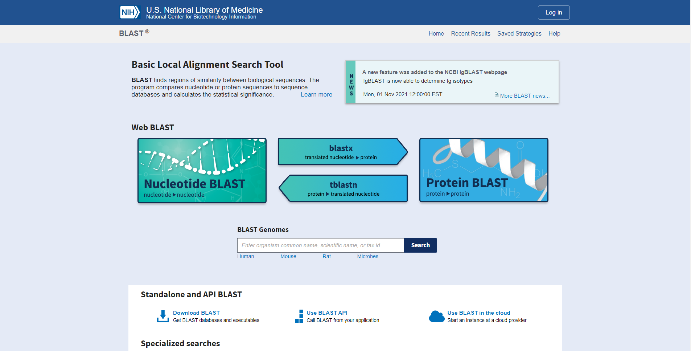Fig1. Homepage of BLAST

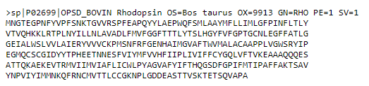Fig2. FASTA sequences for query Rhodopsin

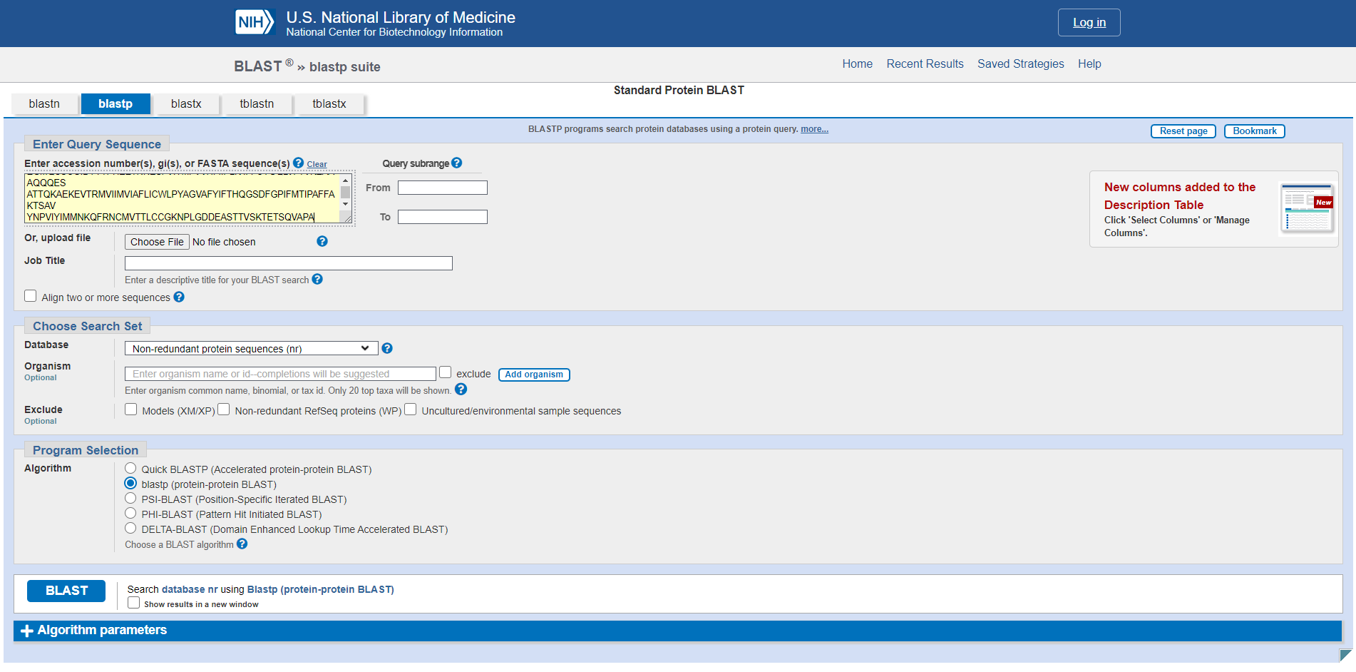Fig3. Search bar for PHI blast with sequence pasted

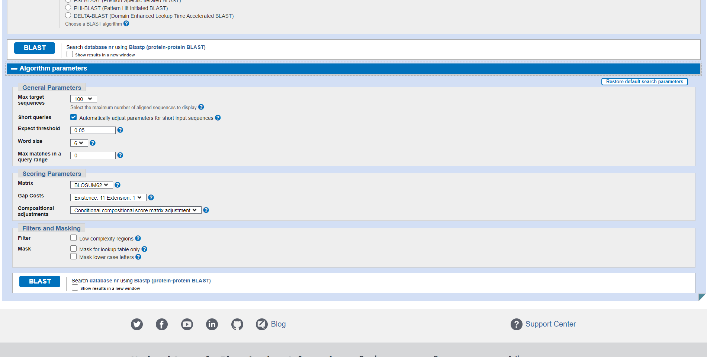Fig4. Algorithm parameters for PHI blast for Rhodopsin

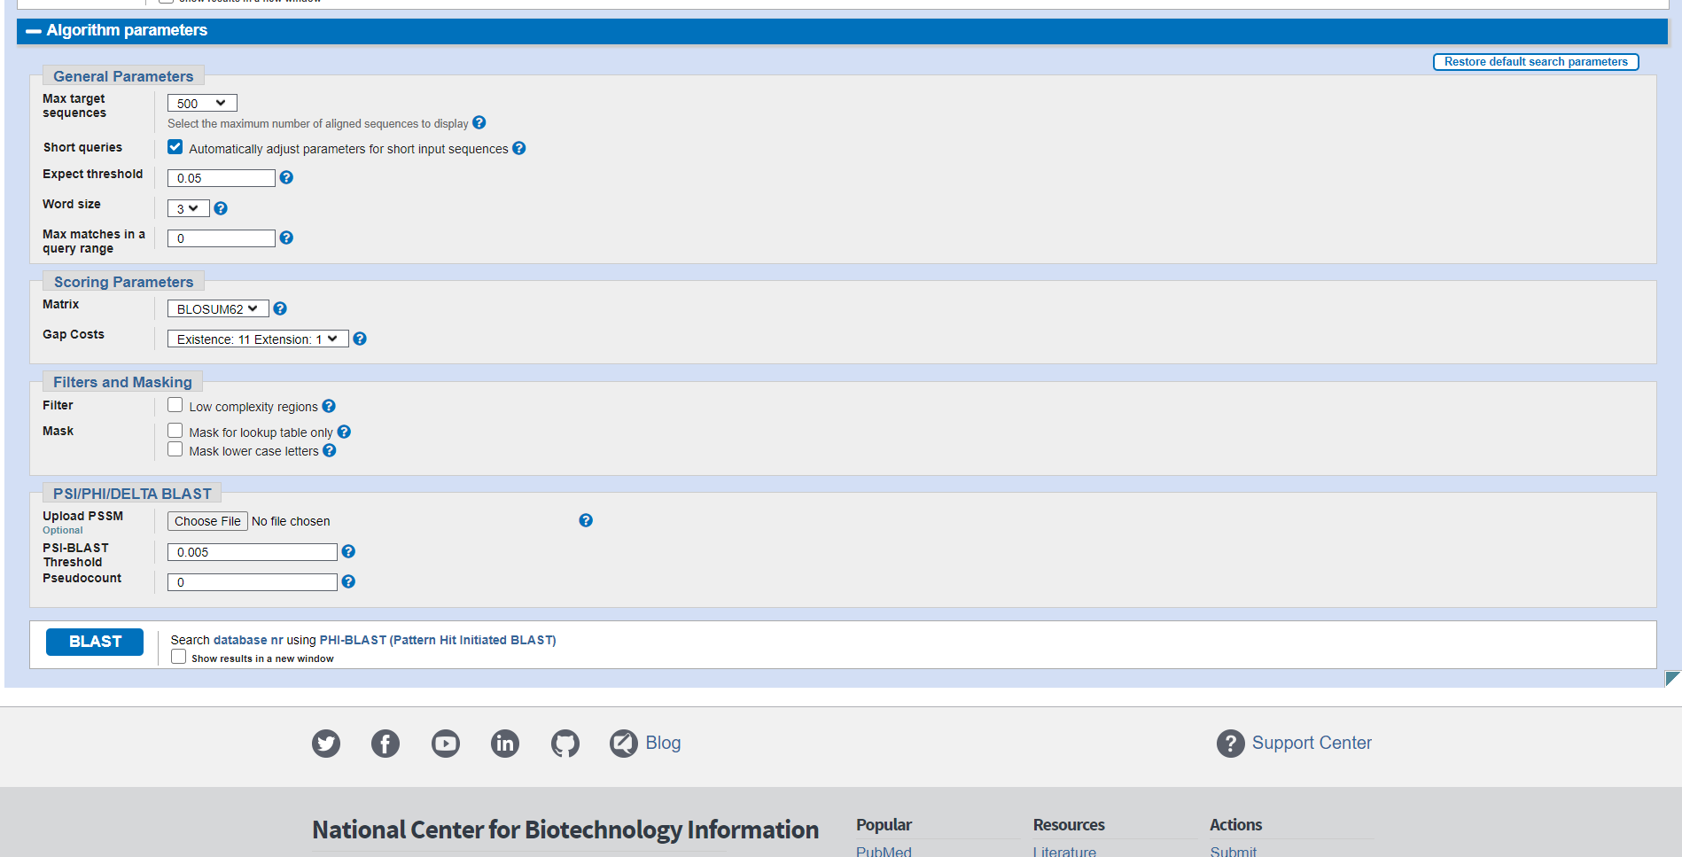Fig5. PSI/PHI/DELTA parameters for Rhodopsin in BLAST

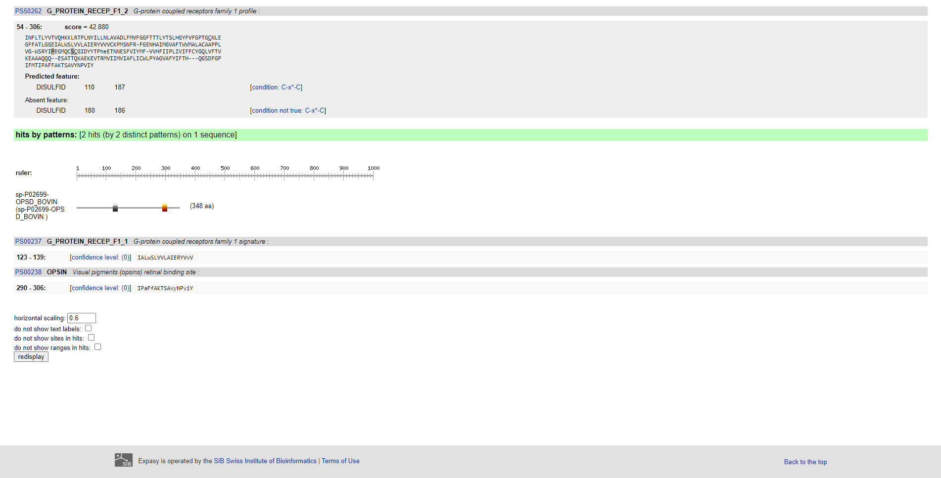Fig6. Pattern for query in Rhodopsin in PROSITE

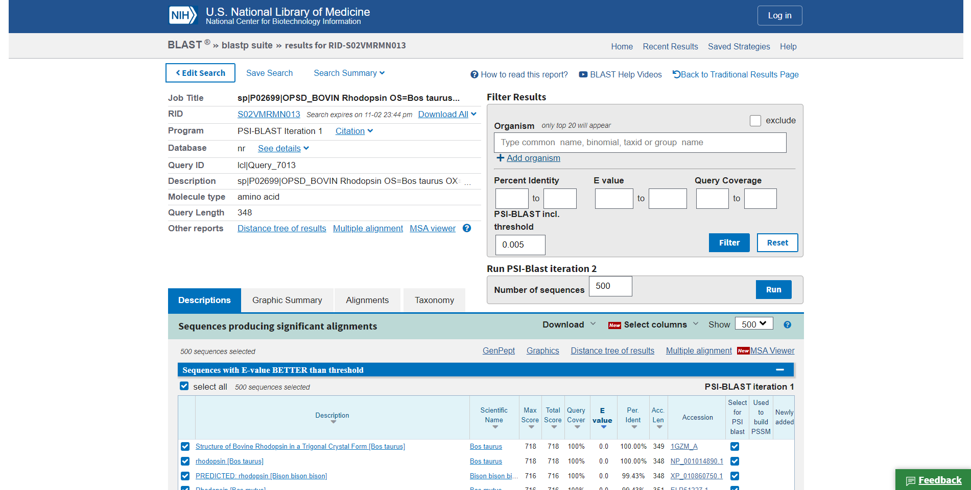Fig7. Result page (header) for Rhodopsin

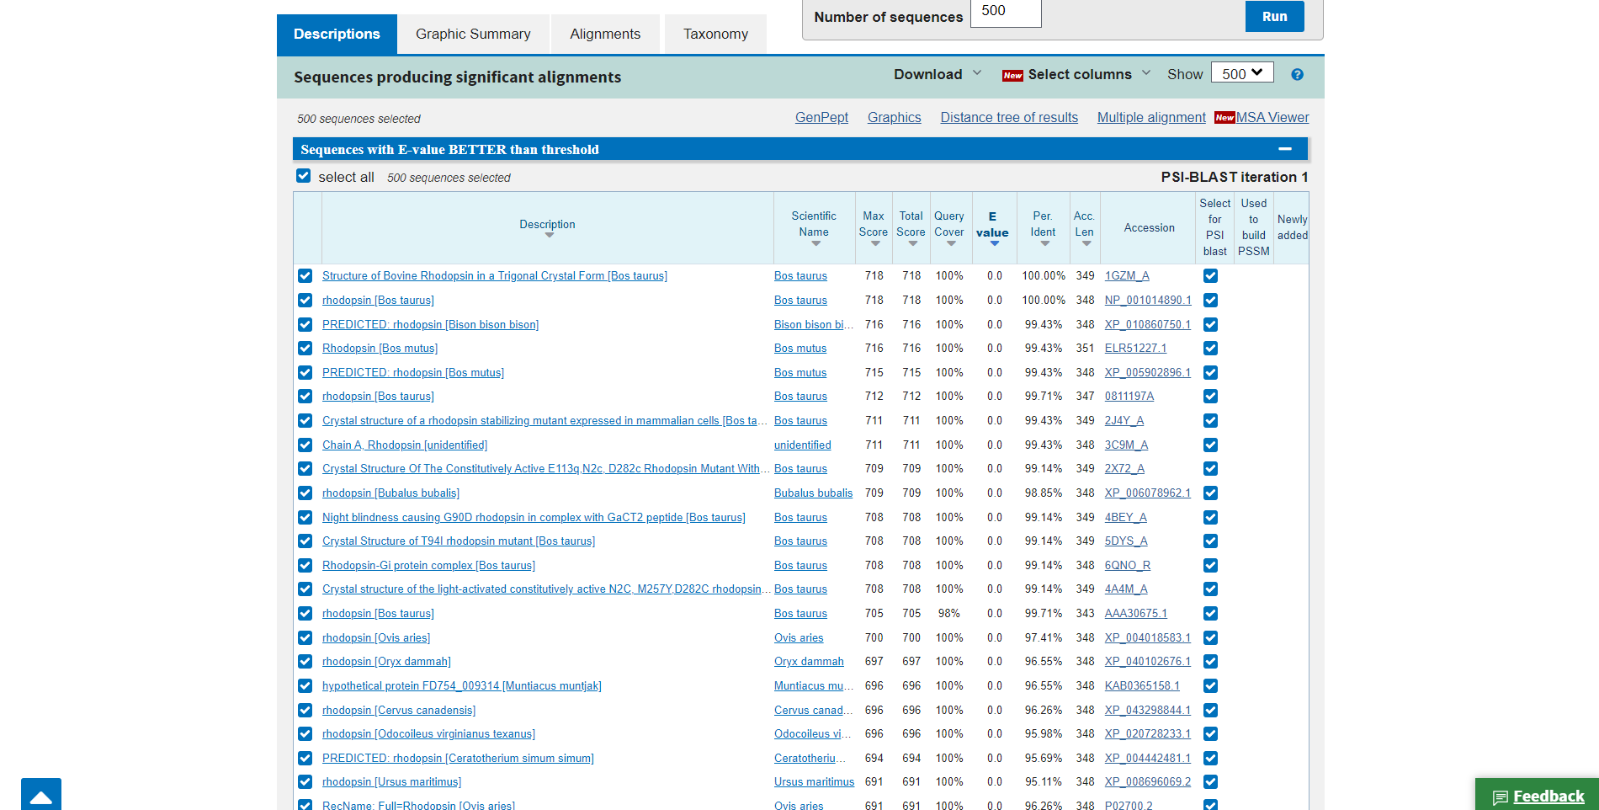Fig8. Description for query Rhodopsin

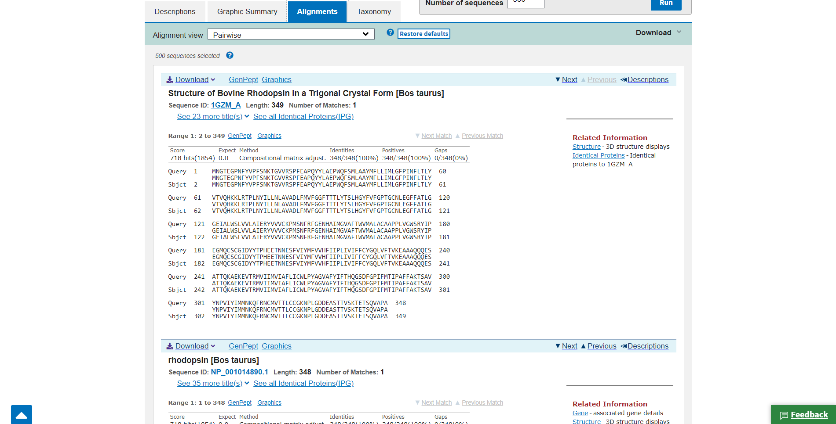Fig9. Alignments view for query Rhodopsin

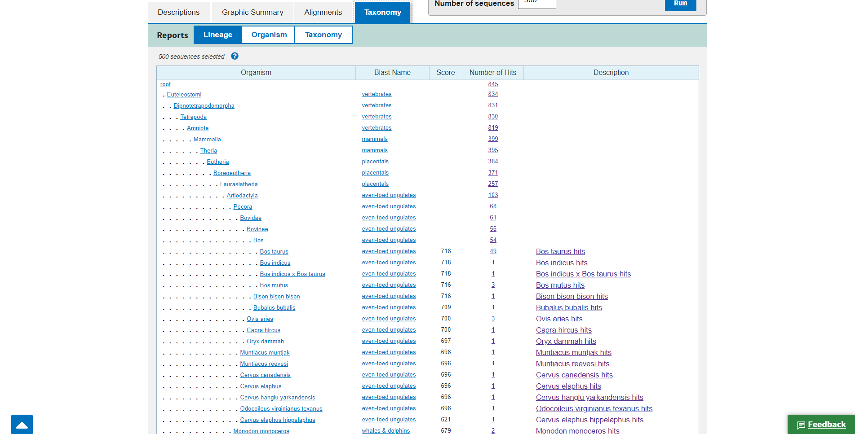Fig10. Taxonomy for Query Rhodopsin

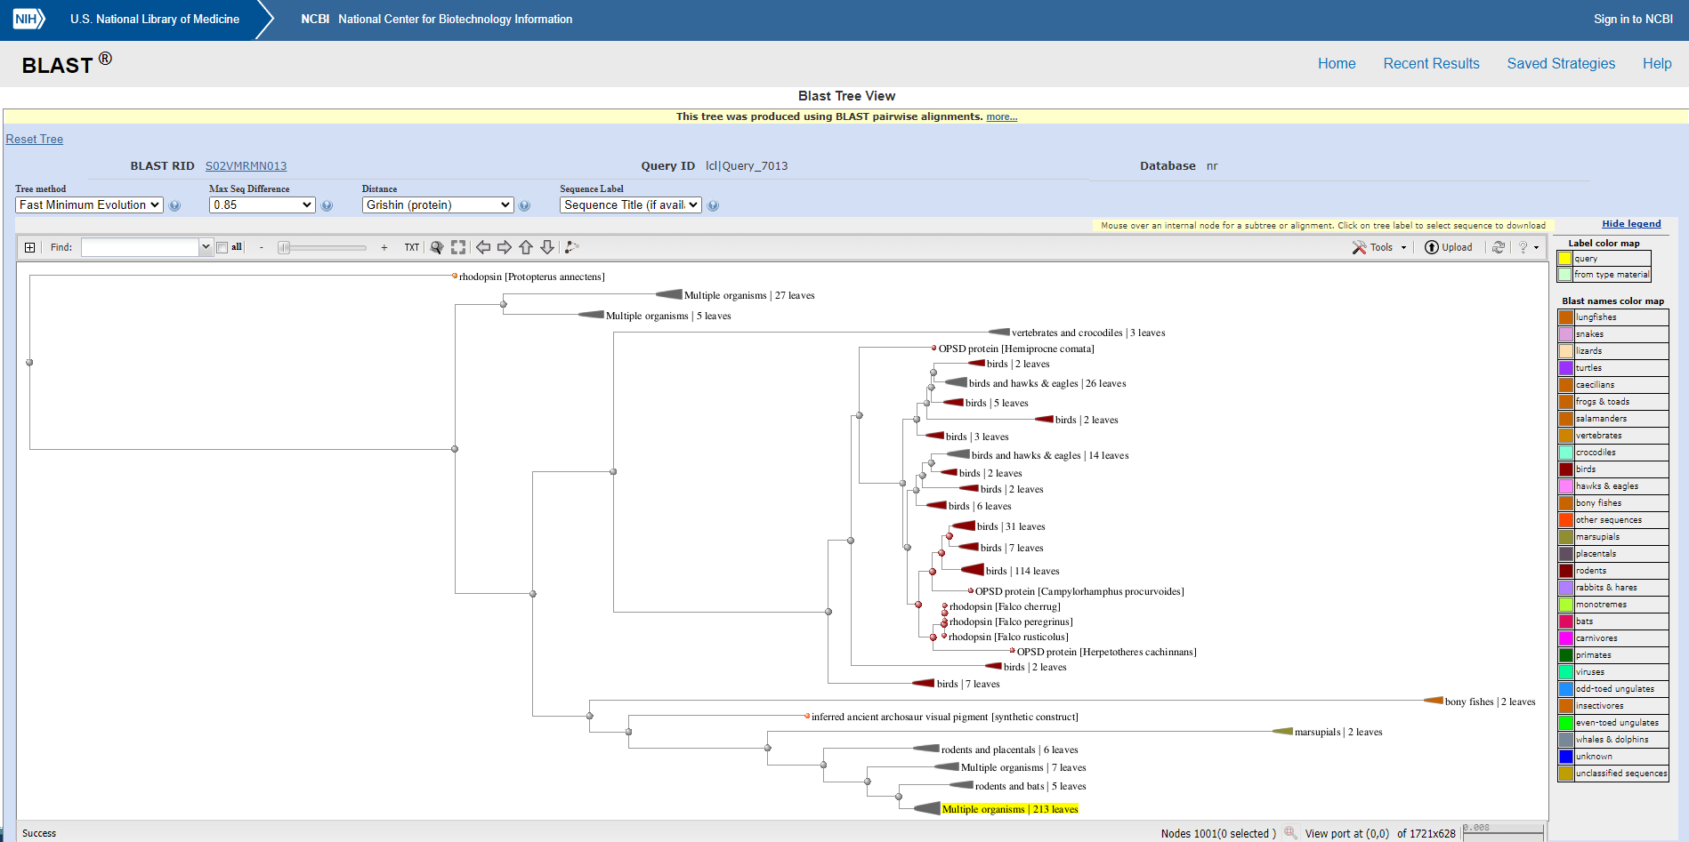Fig11. Blast tree view for Rhodopsin

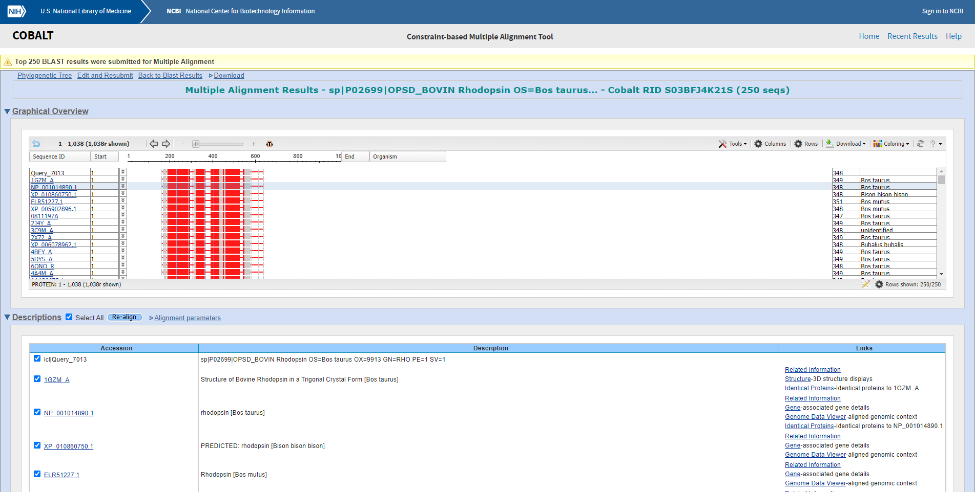Fig12: Multiple alignment view via cobalt for rhodopsin

Results:
In PHI-BLAST the result is divided into 4 parts. Description, Graphic summary alignment, taxonomy. We can also access other tools from within the result page like BLAST tree view and COBALT.

Conclusion:
PHI-BLAST (Pattern-Hit Initiated BLAST) is a search program that combines matching of regular expressions with local alignments surrounding the match. The most important features of the program have been incorporated into the BLAST software framework.

References:
- (n.d.). Retrieved from https://www.uniprot.org/uniprot/P02699.fasta
- Blast Tree View Widget. (n.d.). Retrieved from https://blast.ncbi.nlm.nih.gov/blast/treeview/treeView.cgi?request=page&blastRID=S02VMRMN013&queryID=lcl|Query_7013&entrezLim=&ex=&exl=&exh=&ns=500
- COBALT:Multiple Alignment Tool. (n.d.). Retrieved from https://www.st-va.ncbi.nlm.nih.gov/tools/cobalt/cobalt.cgi
- Expasy is operated by the SIB Swiss Institute of Bioinformatics | Terms of Use. (n.d.). PROSITE. Retrieved from https://prosite.expasy.org/cgi-bin/prosite/ScanView.cgi?scanfile=97965544372.scan.gz
- Protein BLAST: Search protein databases using a protein query. (n.d.). Retrieved from https://blast.ncbi.nlm.nih.gov/Blast.cgi?PROGRAM=blastp&PAGE_TYPE=BlastSearch&BLAST_SPEC=&LINK_LOC=blasttab&LAST_PAGE=blastn
- Rhodopsin. (n.d.). Retrieved from https://www.britannica.com/science/rhodopsin

DATE: 1-11-21
WEBLEM 11/f
(URL: https://blast.ncbi.nlm.nih.gov/Blast.cgi/)

Aim:
To study the query Rhodopsin in PSI BLAST.

Introduction:
A sequence similarity search often provides the first information about a new DNA or protein sequence. A search allows scientists to infer the function of a sequence from similar sequences. There are many ways of performing a sequence similarity search, but probably the most popular method is the “Basic Local Alignment Search Tool” (BLAST) (1, 2). BLAST uses heuristics to produce results quickly. It also calculates an “expect value” that estimates how many matches would have occurred at a given score by chance, which can aid a user in judging how much confidence to have in an alignment. PSI-BLAST first performs a BLASTP search to collect information that it then uses to produce a Position-Specific-Scoring-Matrix (PSSM). A PSSM for a query of length N is an N x 20 matrix. Each of the N columns corresponds to a letter in the query, and each column contains 20 rows. Each row corresponds to a specific residue and describes the probability of related sequences having that residue at that position. PSI-BLAST can then search a database of protein sequences with this PSSM.

Rhodopsin, also called visual purple, pigment-containing sensory protein that converts light into an electrical signal. Rhodopsin is found in a wide range of organisms, from vertebrates to bacteria. In many seeing animals, including humans, it is required for vision in dim light and is located in the retina of the eye specifically, within the tightly packed disks that make up the outer segment of the retina’s photoreceptive rod cells, which are specially adapted for vision under low-light conditions. Rhodopsin was discovered in 1876 by German physiologist Franz Christian Boll, who observed that the normally reddish- purple frog retina turned pale in bright light. The fading of colour was later attributed to the destruction of rhodopsin, via a process known as bleaching. Bleaching and the subsequent regeneration of rhodopsin are major steps in the visual cycle—the series of biochemical reactions that is critical for vision in low light.

Methodology:
- Open the homepage of BLAST.
- After that click the BLASTp hyperlink
- Enter the sequence for Rhodopsin taken from uniport
- Change the program selection algorithm to PSI-BLAST
- Change the PSI-BLAST threshold value (0.0001)
- Open the result page.
- Interpret the results.

Observations:
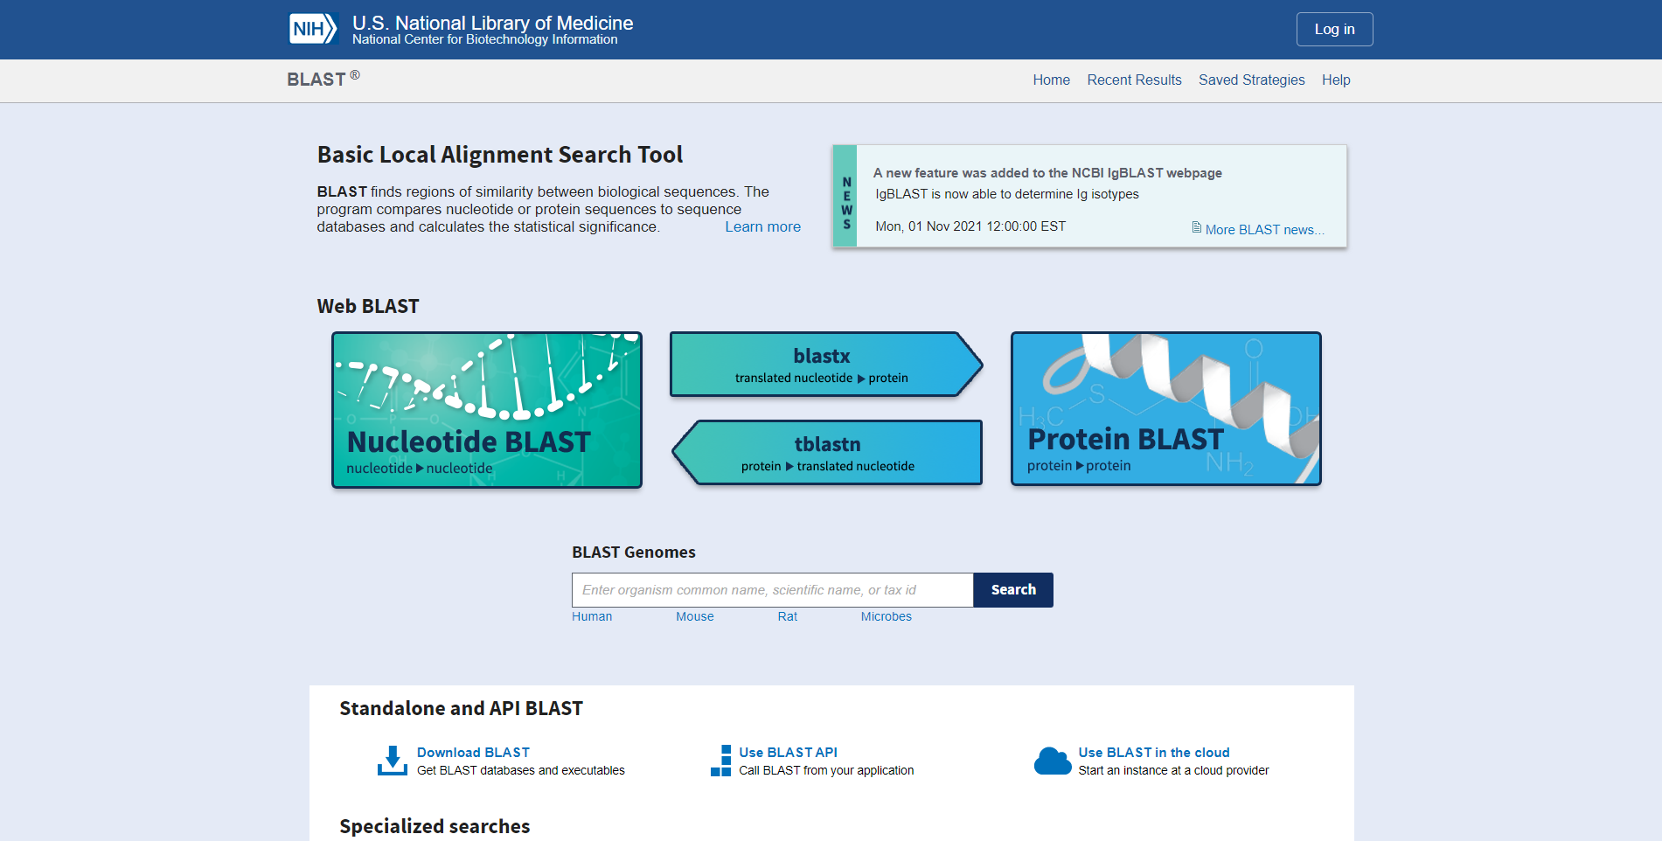Fig1. Homepage of BLAST

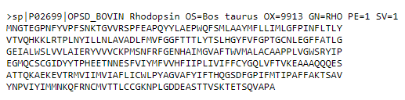Fig2. FASTA sequence for Rhodopsin

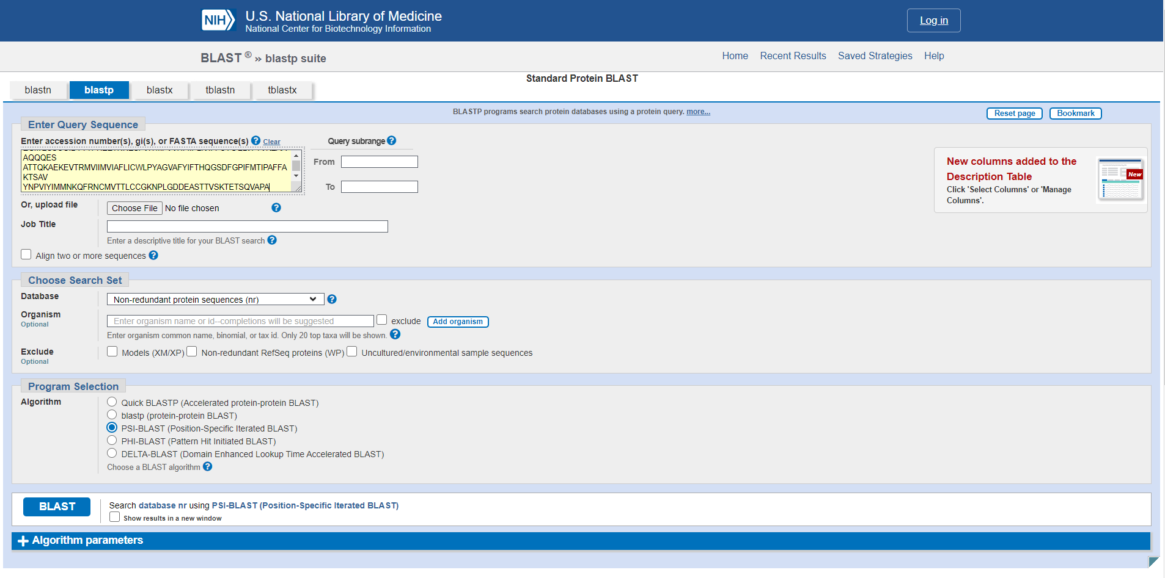Fig3. Search bar for PSI blast with sequence for rhodopsin taken from uniport

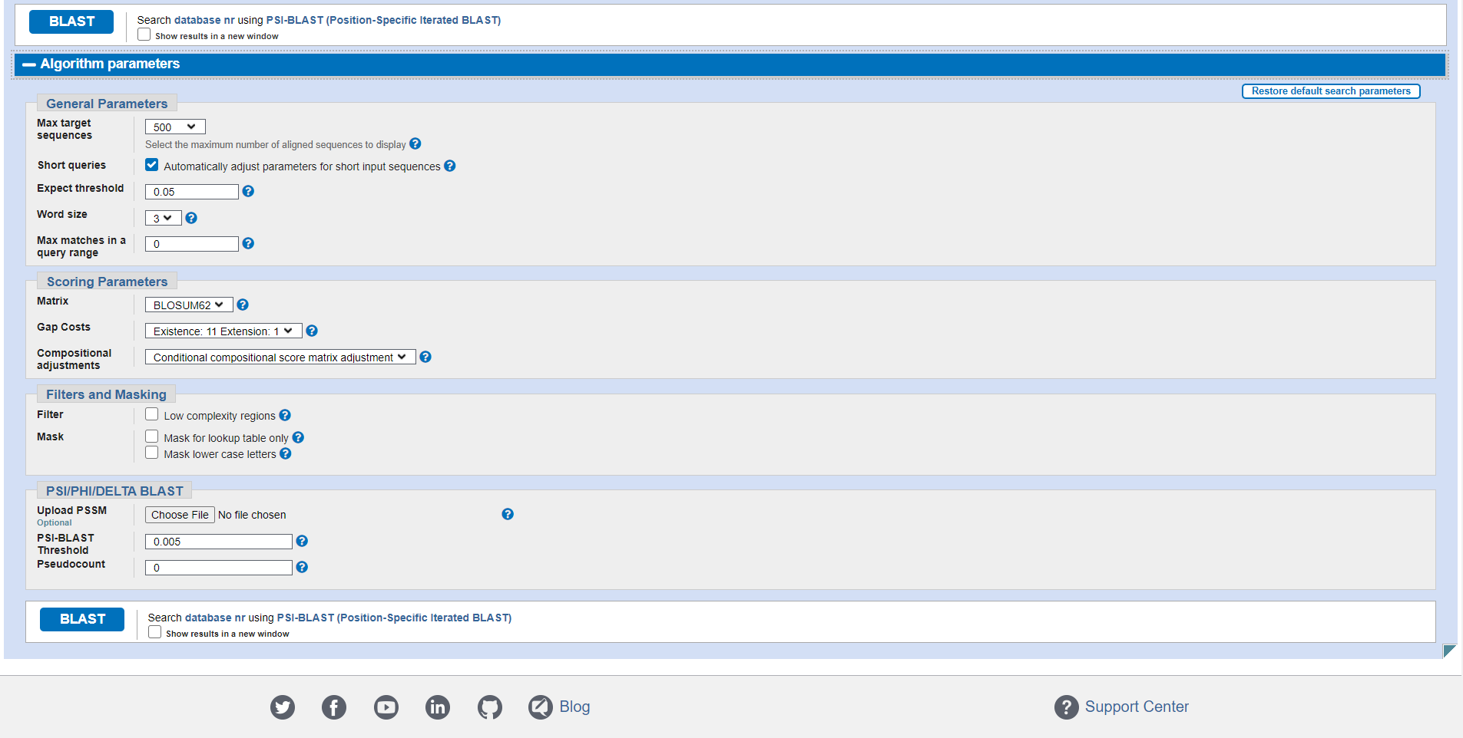Fig4. Algorithm parameters (General, Scoring, Filters, Masking)

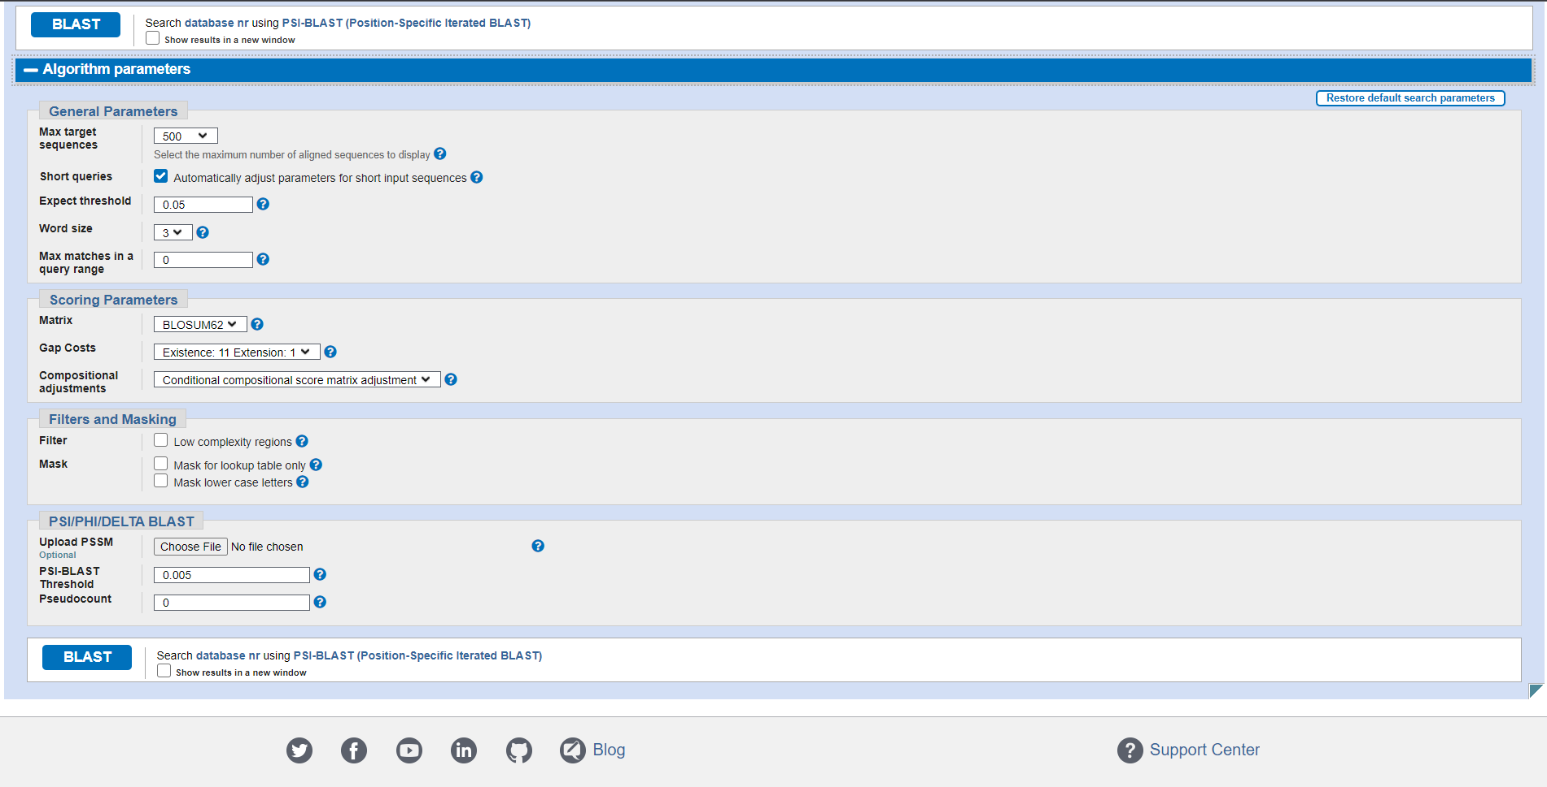Fig5. Algorithm parameters for PSI/PHI/DELTA BLAST

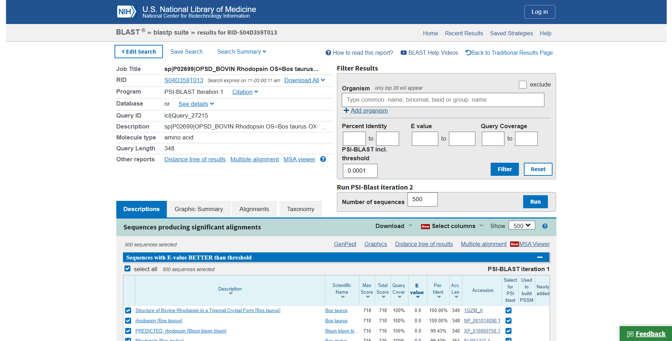Fig6. Result page (header) for rhodopsin in PSI-BLAST

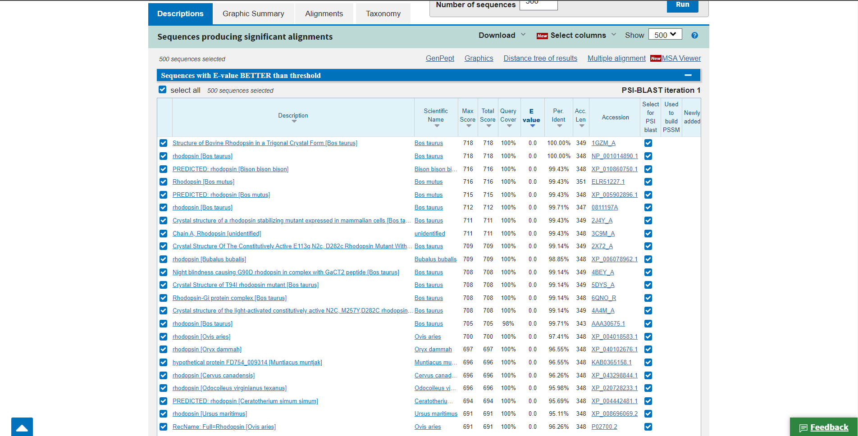Fig7. Description for query Rhodopsin in PSI-BLAST

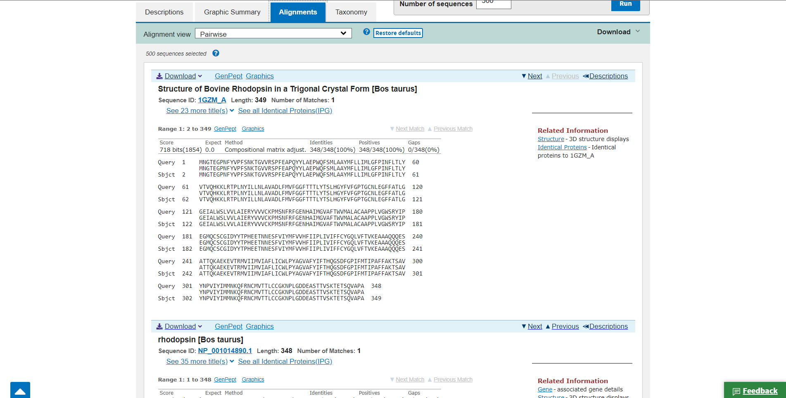Fig8. Alignments for query Rhodopsin in PSI-BLAST

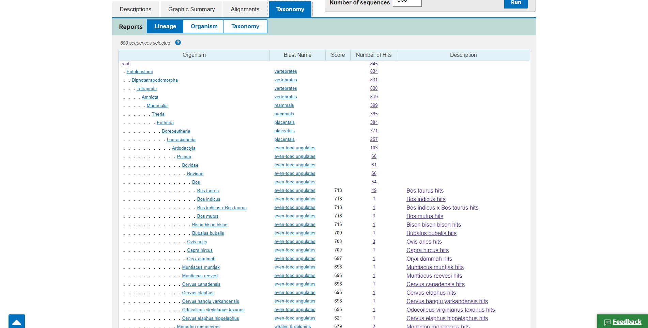Fig9. Taxonomy for Rhodopsin in PSI-BLAST

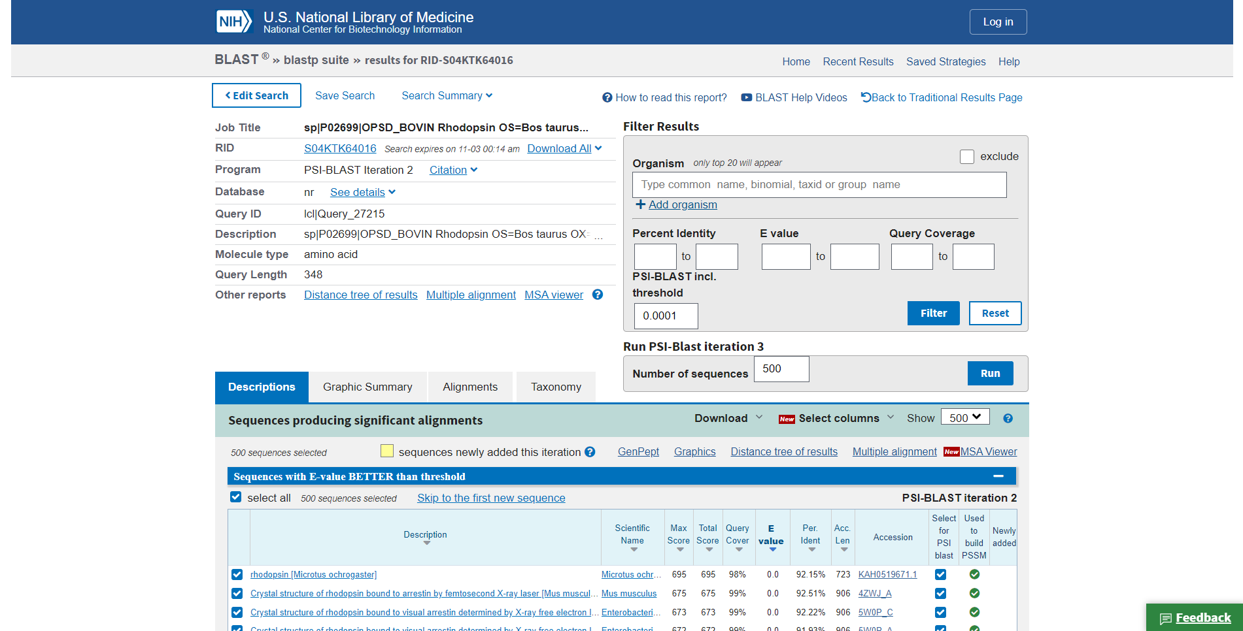Fig10. Result page for Iteration 1

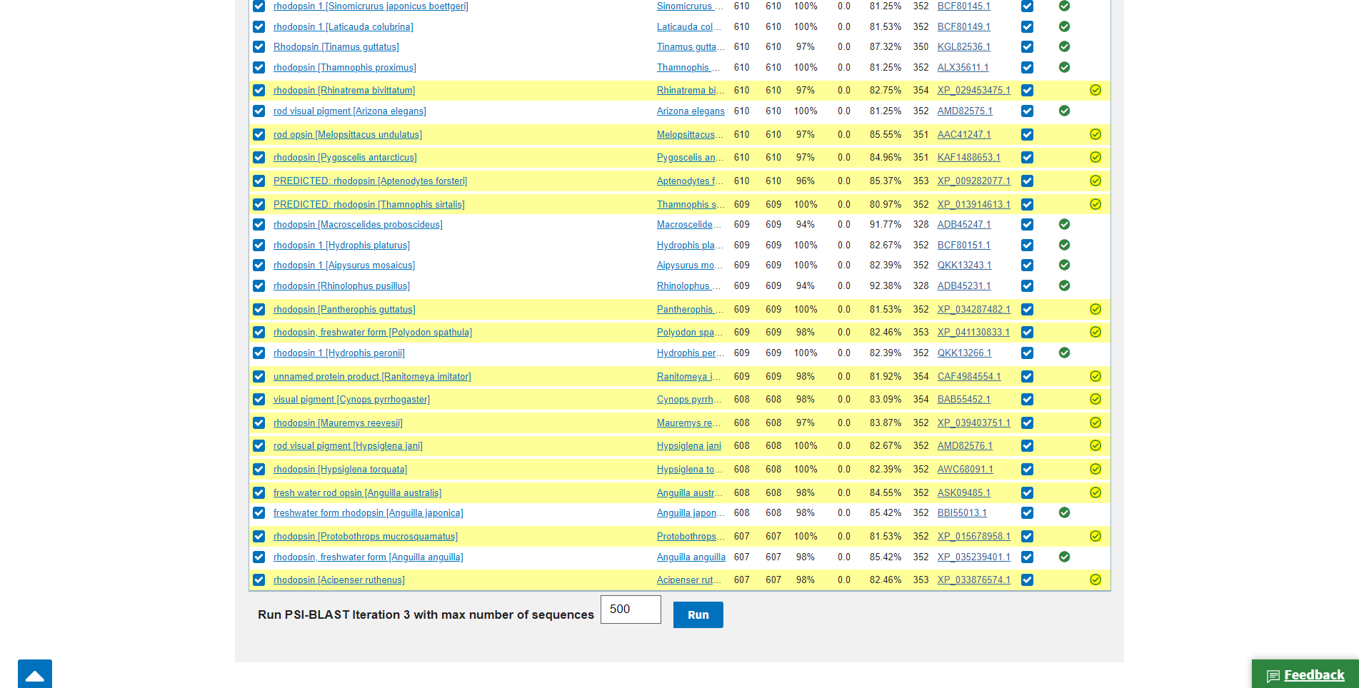Fig11. Newly added sequences in iteration 1

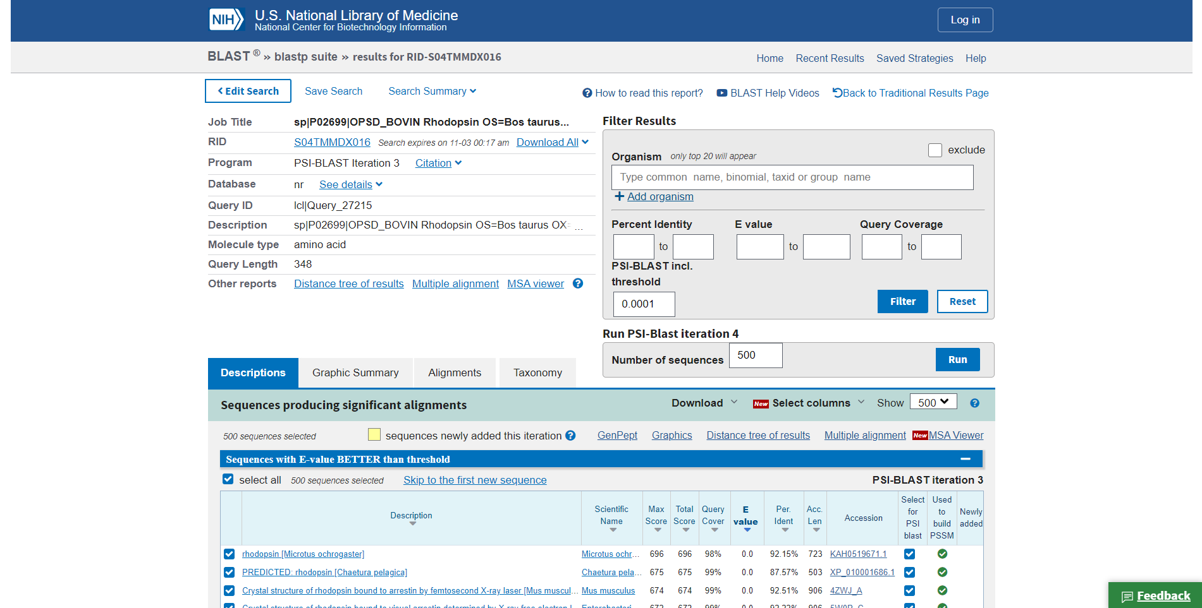Fig12. Result page for Iteration 2

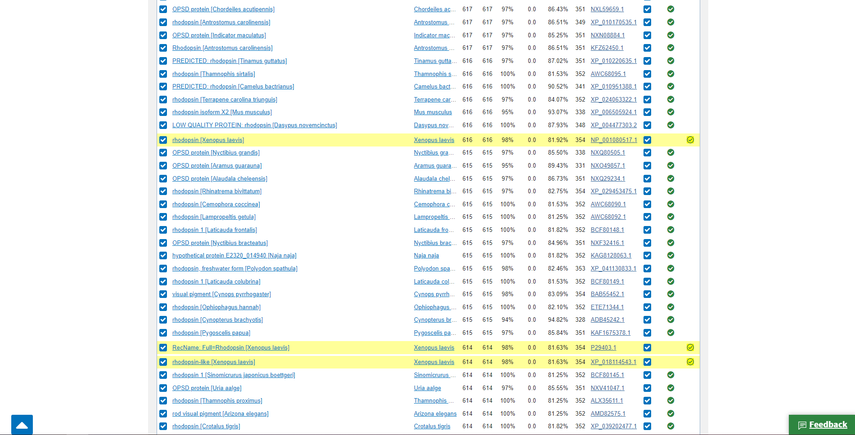Fig13. Newly found sequences in Iteration 2

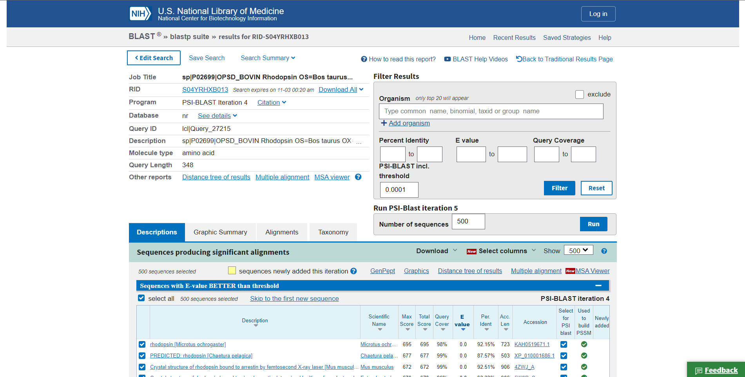Fig14. Result page for Iteration 3

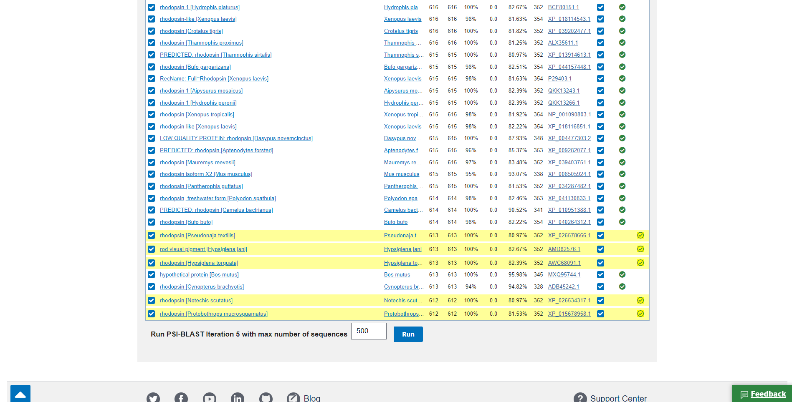Fig15. Newly found sequences in Iteration 3

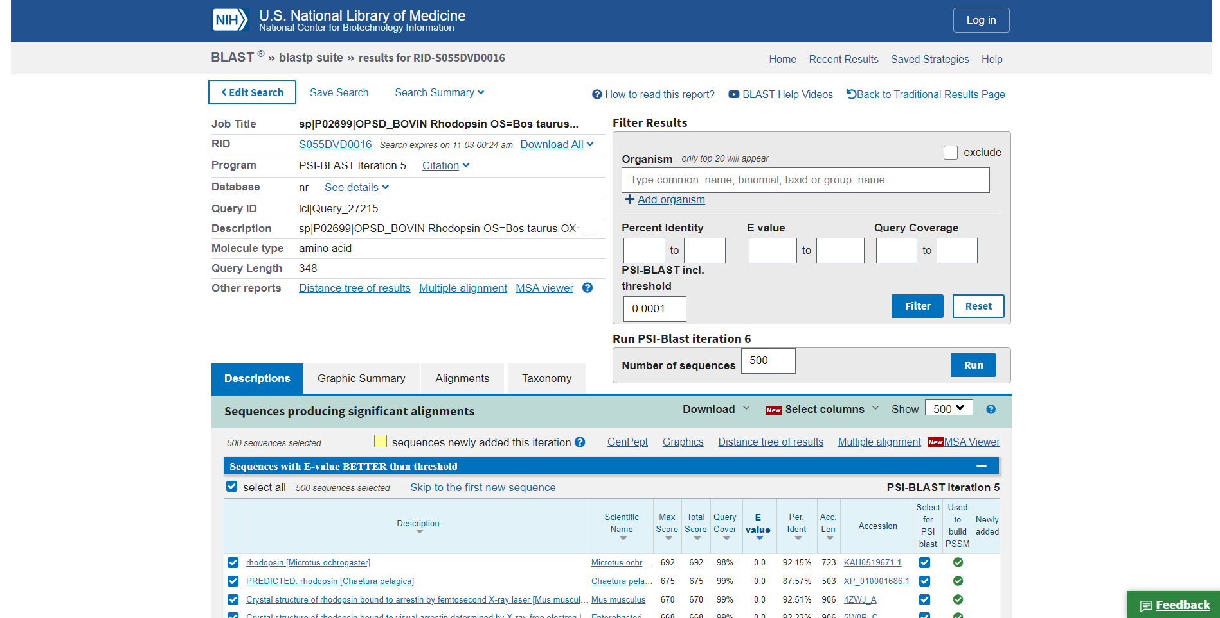Fig16. Result page for iteration 4

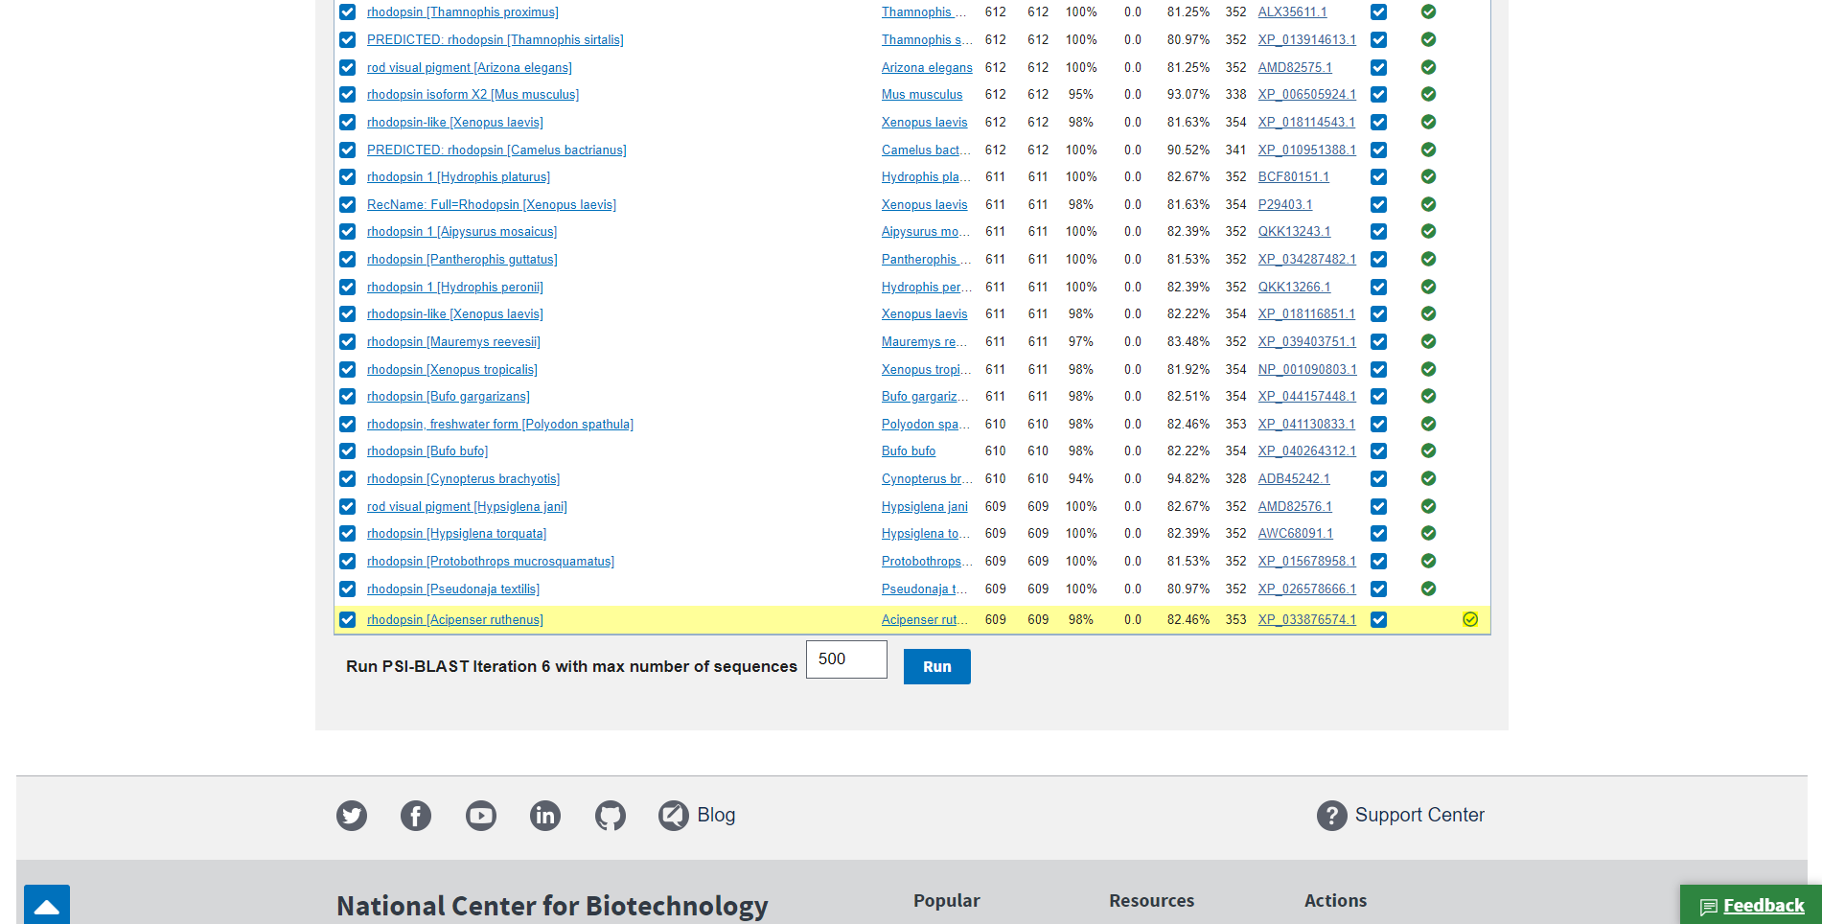Fig17. Newly found sequences in Iteration 4

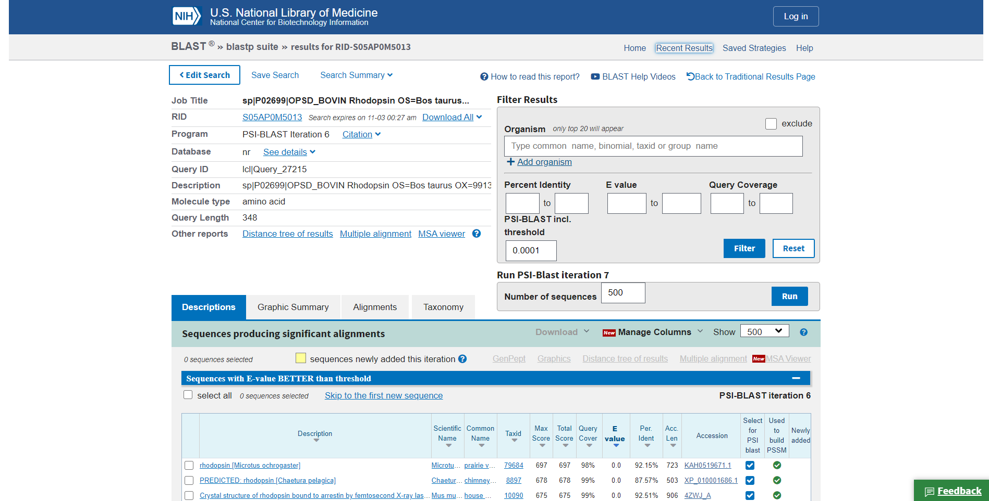Fig18. Result page for Iteration 5

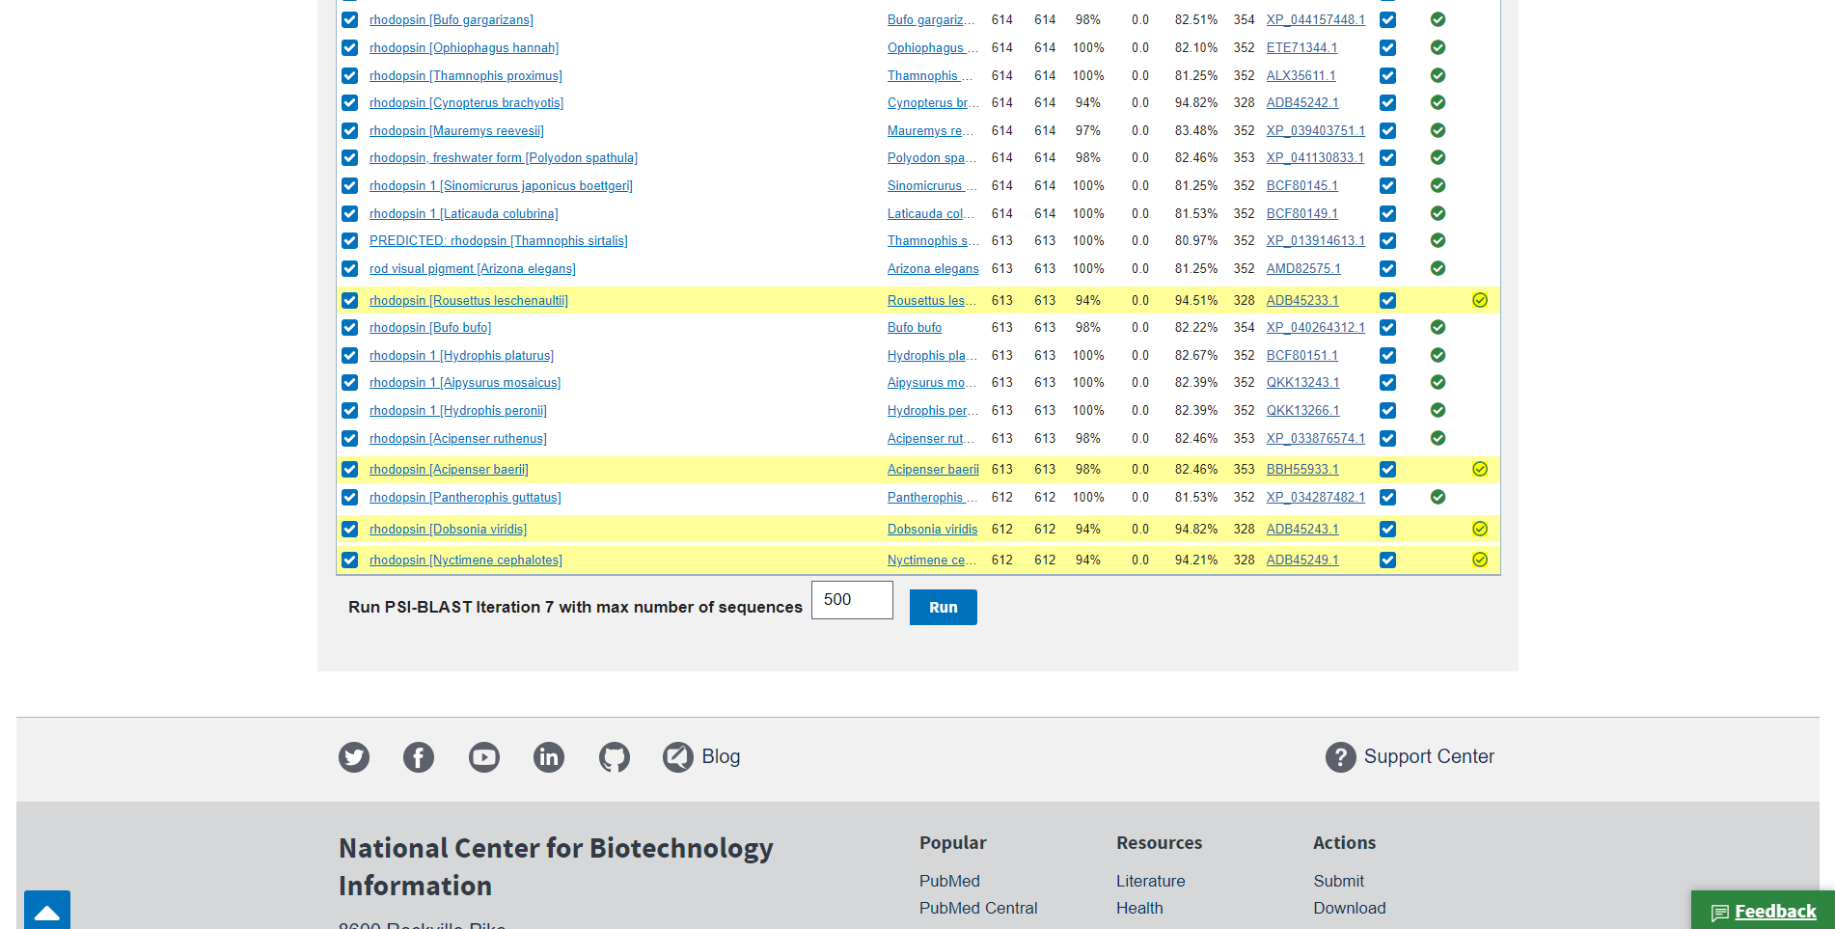Fig19. Newly found sequences in iteration 5

Results:
In PHI-BLAST the result is divided into 4 parts. Description, Graphic summary alignment, taxonomy. We can also iterate through multiple result pages where the database searches for more and more sequence alignments

Conclusion:
The PSI-blast is used to find distantly related proteins, what you need is the results in the final iteration. The PSI-blast runs in the following five steps: Repeat steps [3] and [4] iteratively, typically 5 times. At each new search, a new PSSM is used as the query. Hope my answer could help you to understand the use of PSI-blast.

References:
- (n.d.). Retrieved from https://www.uniprot.org/uniprot/P02699.fasta
- NCBI Blast:sp|P02699|OPSD_BOVIN Rhodopsin OS=Bos taurus... (n.d.). Retrieved from https://blast.ncbi.nlm.nih.gov/Blast.cgi?CMD=Get&VIEW_RESULTS=FromRes&RID=S04D359T013&UNIQ_OBJ_NAME=A_SearchResults_1mhZtz_215p_diTIoYKm2MJ_GTXQl_fSITZ&QUERY_INDEX=0
- NCBI Blast:sp|P02699|OPSD_BOVIN Rhodopsin OS=Bos taurus... (n.d.). Retrieved from https://blast.ncbi.nlm.nih.gov/Blast.cgi?CMD=Get&VIEW_RESULTS=FromRes&RID=S04KTK64016&UNIQ_OBJ_NAME=A_SearchResults_1mhZxS_8Gf_du382JTU5wJ_GTXQl_1aKLYe&QUERY_INDEX=0
- NCBI Blast:sp|P02699|OPSD_BOVIN Rhodopsin OS=Bos taurus... (n.d.). Retrieved from https://blast.ncbi.nlm.nih.gov/Blast.cgi?CMD=Get&VIEW_RESULTS=FromRes&RID=S04TMMDX016&UNIQ_OBJ_NAME=A_SearchResults_1mha0S_2tWP_dgi0SViy52a_GTWlT_s8Vrj&QUERY_INDEX=0
- NCBI Blast:sp|P02699|OPSD_BOVIN Rhodopsin OS=Bos taurus... (n.d.). Retrieved from https://blast.ncbi.nlm.nih.gov/Blast.cgi?CMD=Get&VIEW_RESULTS=FromRes&RID=S04YRHXB013&UNIQ_OBJ_NAME=A_SearchResults_1mha36_1HG1_dh5iZ3ya7Ag_GTW6B_1xr8fY&QUERY_INDEX=0
- NCBI Blast:sp|P02699|OPSD_BOVIN Rhodopsin OS=Bos taurus... (n.d.). Retrieved from https://blast.ncbi.nlm.nih.gov/Blast.cgi?CMD=Get&VIEW_RESULTS=FromRes&RID=S055DVD0016&UNIQ_OBJ_NAME=A_SearchResults_1mha6X_2snk_dhWv52Lw3FN_GTWlT_TnXX2&QUERY_INDEX=0
- NCBI Blast:sp|P02699|OPSD_BOVIN Rhodopsin OS=Bos taurus... (n.d.). Retrieved from https://blast.ncbi.nlm.nih.gov/Blast.cgi?CMD=Get&VIEW_RESULTS=FromRes&RID=S05AP0M5013&UNIQ_OBJ_NAME=A_SearchResults_1mha9H_12l1_dwXZcxLU55P_GTXQl_1s3jJ9&QUERY_INDEX=0
- Rhodopsin. (n.d.). Retrieved from https://www.britannica.com/science/rhodopsin

